* 1. Introduction to Memory and Memory parameters.
  2. 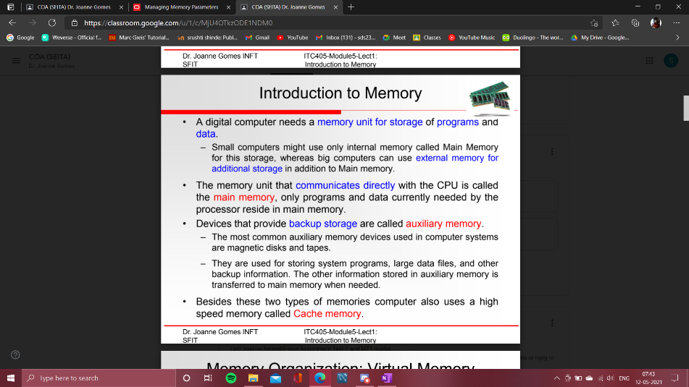

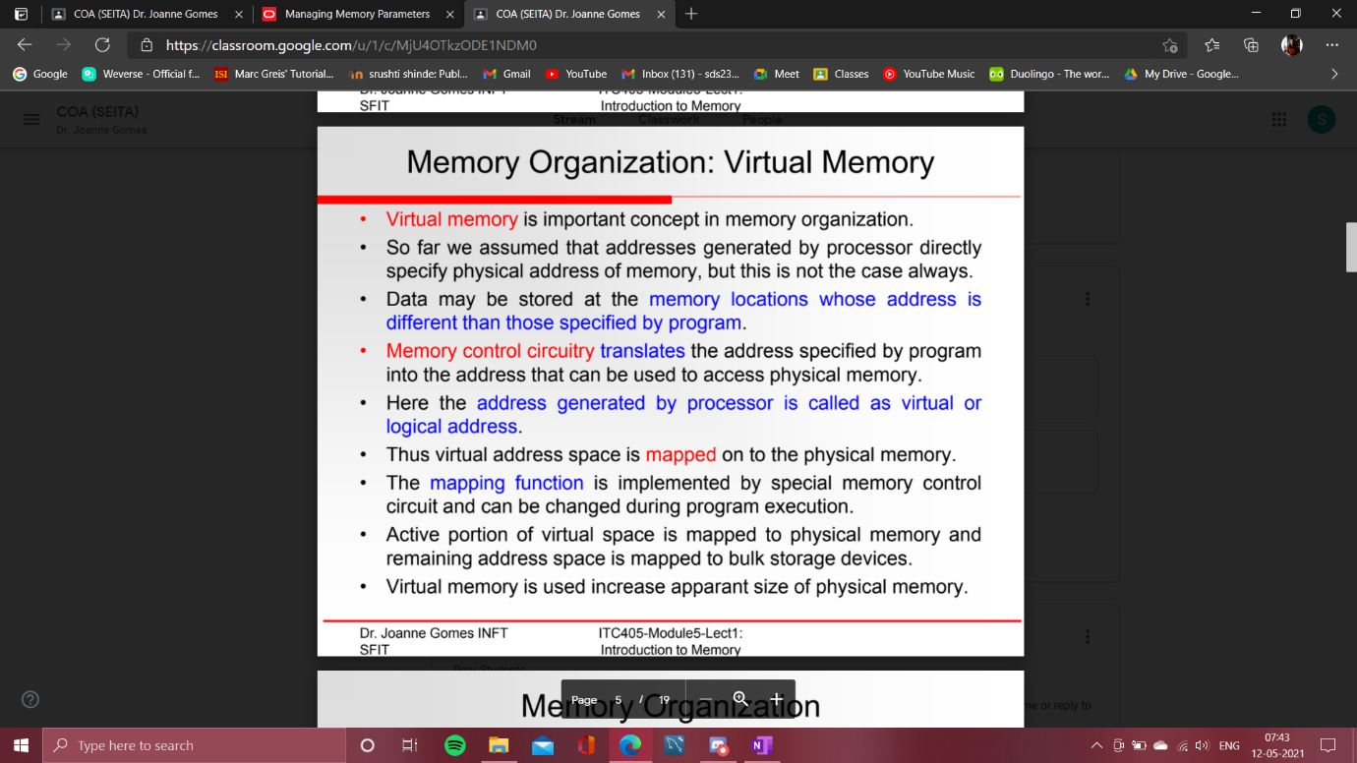

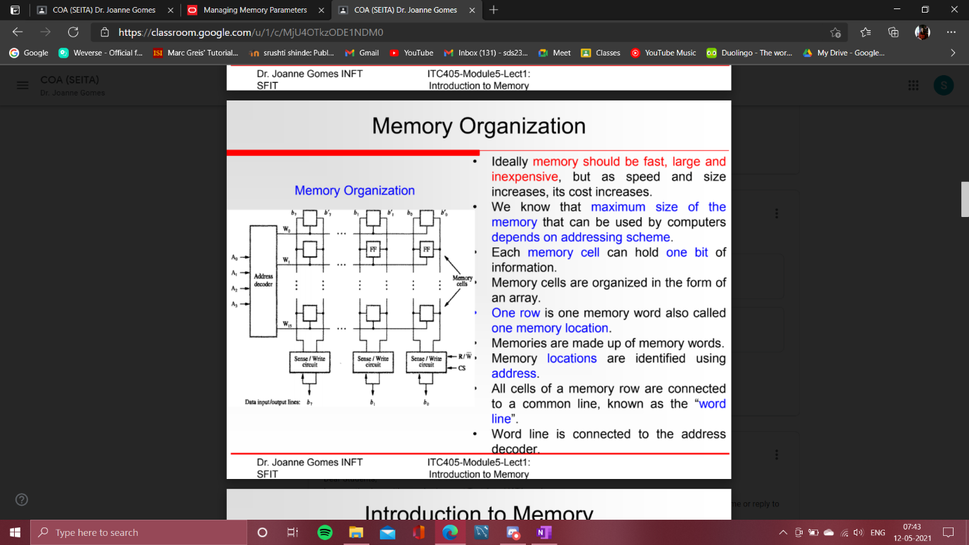

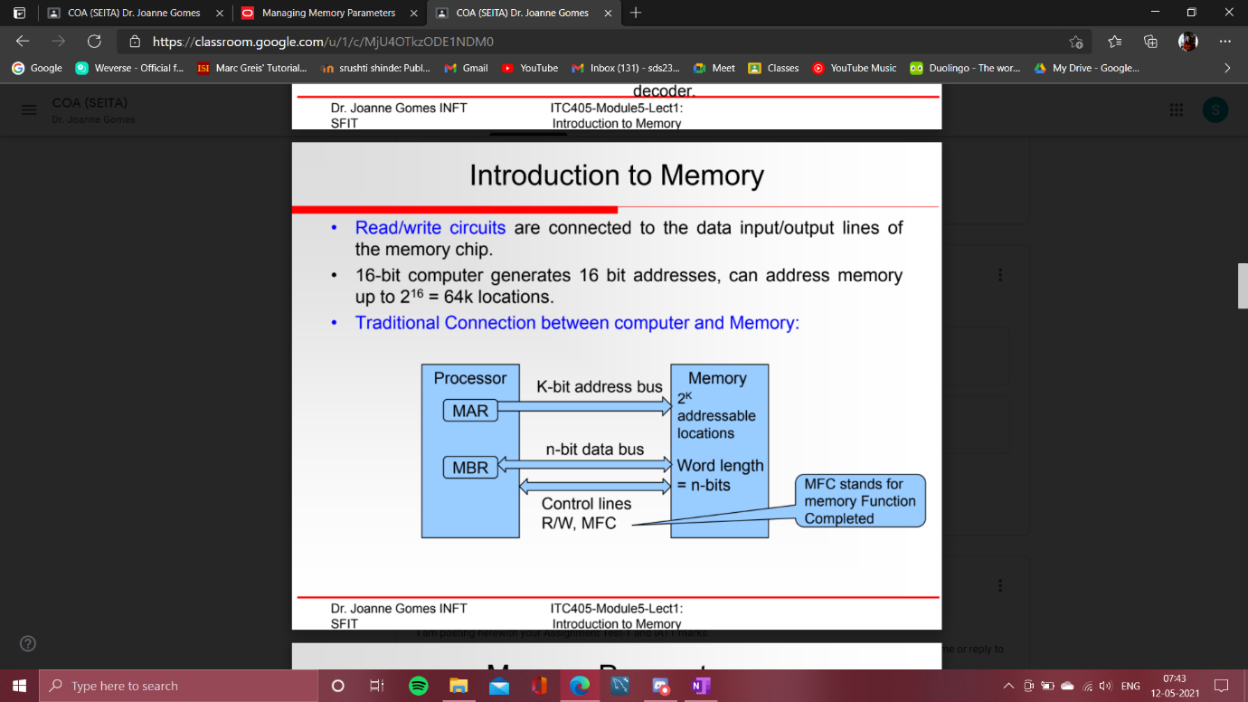

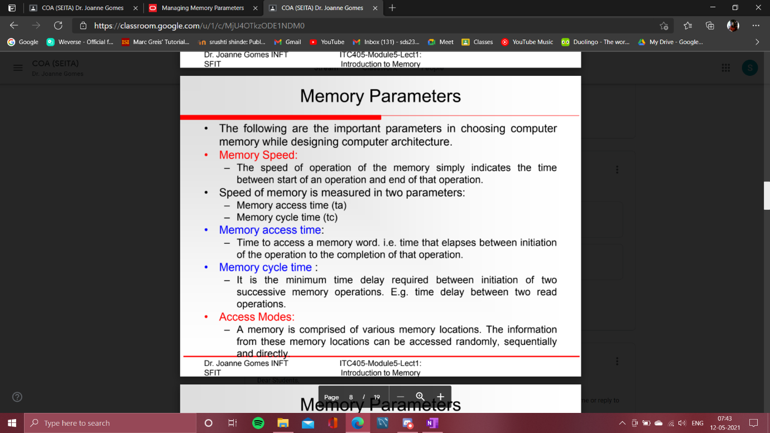

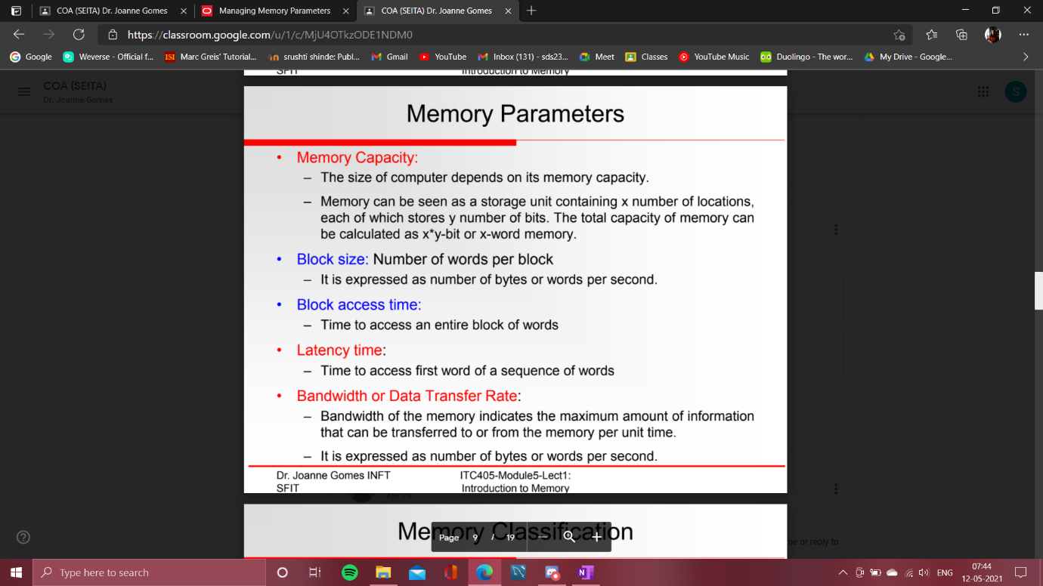

* 1. Classifications of primary and secondary memories.

==>

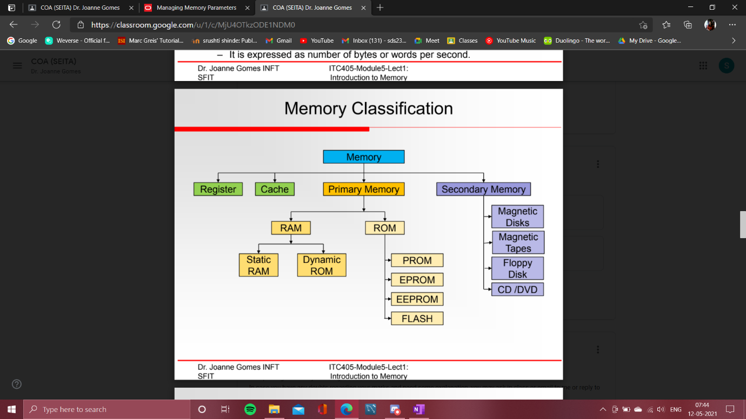

Difference Between Primary and Secondary Memory

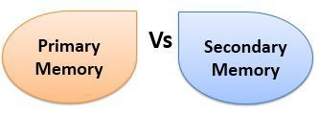

The memory of a computer is classified in the two categories **primary** and **secondary** memory. **Primary memory** is the **main memory** of the computer where the currently processing data resides. The **secondary memory** of the computer is **auxiliary memory** where the data that has to be stored for a **long time** or **permanently,** is kept. The basic difference between primary and secondary memory is that the **primary memory** is **directly accessible by CPU** whereas, the **secondary memory** is **not directly accessible to CPU**.

Comparison Chart

|  |  |  |
| --- | --- | --- |
| **BASIS FOR COMPARISON** | **PRIMARY MEMORY** | **SECONDARY MEMORY** |
| Basic | Primary memory is directly accessible by Processor/CPU. | Secondary memory is not directly accessible by CPU. |
| Altered Name | Main memory. | Auxiliary memory. |
| Data | Instructions or data to be currently executed are copied to main memory. | Data to be permanently stored is kept in secondary memory. |
| Volatility | Primary memory is usually volatile. | Secondary memory is non-volatile. |
| Formation | Primary memories are made of semiconductors. | Secondary memories are made of magnetic and optical material. |
| Access Speed | Accessing data from primary memory is faster. | Accessing data from secondary memory is slower. |
| Access | Primary memory is accessed by the data bus. | Secondary memory is accessed by input-output channels. |
| Size | The computer has a small primary memory. | The computer has a larger secondary memory. |
| Expense | Primary memory is costlier than secondary memory. | Secondary memory is cheaper than primary memory |
| Memory | Primary memory is an internal memory. | Secondary memory is an external memory. |

Definition of Primary Memory

Primary memory is the **main memory** of computer system. The instructions that have to be**currently executed** is copied to the primary memory because CPU can directly access the data from primary memory. Accessing data from primary memory is **faster** as it is an **internal memory** and processor accesses data from primary memory using **data bus**.

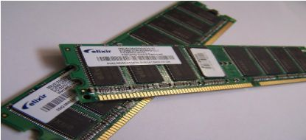

The primary memory is usually **volatile** in nature which means data in primary memory does not exist if not saved, in case the **power failure** occurs. The primary memory is **semiconductor memory** and is more **expensive** than secondary memory. The primary memory capacity is **limited** in computer and is always **smaller** than secondary memory.

Primary memory can be divided into two types of memory that are **RAM** (**Random Access Memory**) and **ROM** (**Read Only Memory**).

* + **RAM** is both **read and write** memory. The data which has to be currently processed is kept in RAM which can be quickly accessed by the CPU. RAM is **volatile** and loses data if the power is switched off. RAM can be **static** or **dynamic**.
  + **ROM** is a **read only** memory; its content can **not** be **altered**. It has the instructions that are used when the system is **booted up**. ROM is a **non-volatile** memory i.e. it retains its content even if the power is switched off. The types of ROM are **PROM**, **EPROM** and **EEPROM**.

Definition of Secondary Memory

Secondary memory is an **auxiliary memory** of the computer. The data that has to be **permanently** stored is kept in secondary memory. The CPU can **not directly access** the data in secondary memory. The data has to be initially copied to primary memory then only it can be processed by CPU. Hence, accessing data from secondary memory is **slower**. The secondary memory can be accessed using the **input-output channel**.

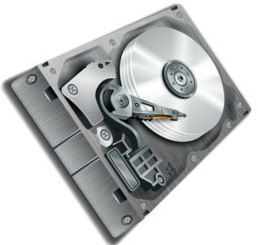

The secondary memory is **nonvolatile** in nature, which means that the content of the secondary memory exist even if the power is switched off. The secondary memory is **magnetic memory**or**optical memory** and it available at **cheaper** rates as compared to the primary memory.

Secondary memory is available in **bulk** and always **larger** than primary memory. A computer can even work without secondary memory as it an **external memory**. The examples of secondary memory are the **hard disk, floppy disk, CD, DVD, etc**.

Key Differences Between Primary and Secondary Memory

* + The key difference between primary and secondary memory is that primary memory can be **directly accessed by the CPU** whereas, the **CPU can not directly access** the secondary memory.
  + The primary memory of the computer is also known as the **main memory** of the computer. However, secondary memory is known as **auxiliary memory**.
  + The data that is to be **currently processed** is in primary memory whereas, the data that has to be **permanently stored** is kept in secondary memory.
  + Primary memory is a **volatile** memory whereas, the secondary memory is a **non-volatile** memory.
  + Primary memories are **semiconductor memories** whereas; the secondary memories are the**magnetic and optical memories**.
  + Data accessing speed of the primary memory is **faster** than secondary memory.
  + Primary memory is accessed by the **data bus**. On the other hand, secondary memory is accessed using**input-output channels**.
  + Primary memory’s capacity is always **smaller** than secondary memory’s capacity.
  + Primary memory is **costlier** than secondary memory.
  + Primary memory is an **internal memory** whereas, secondary memory is an **external memory**.

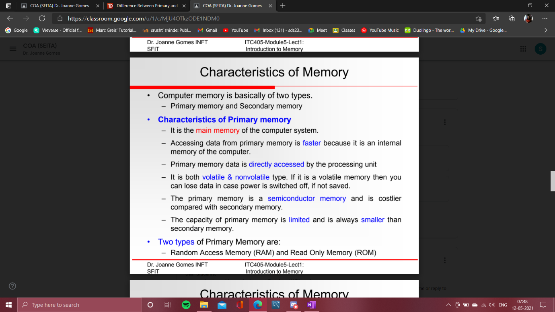

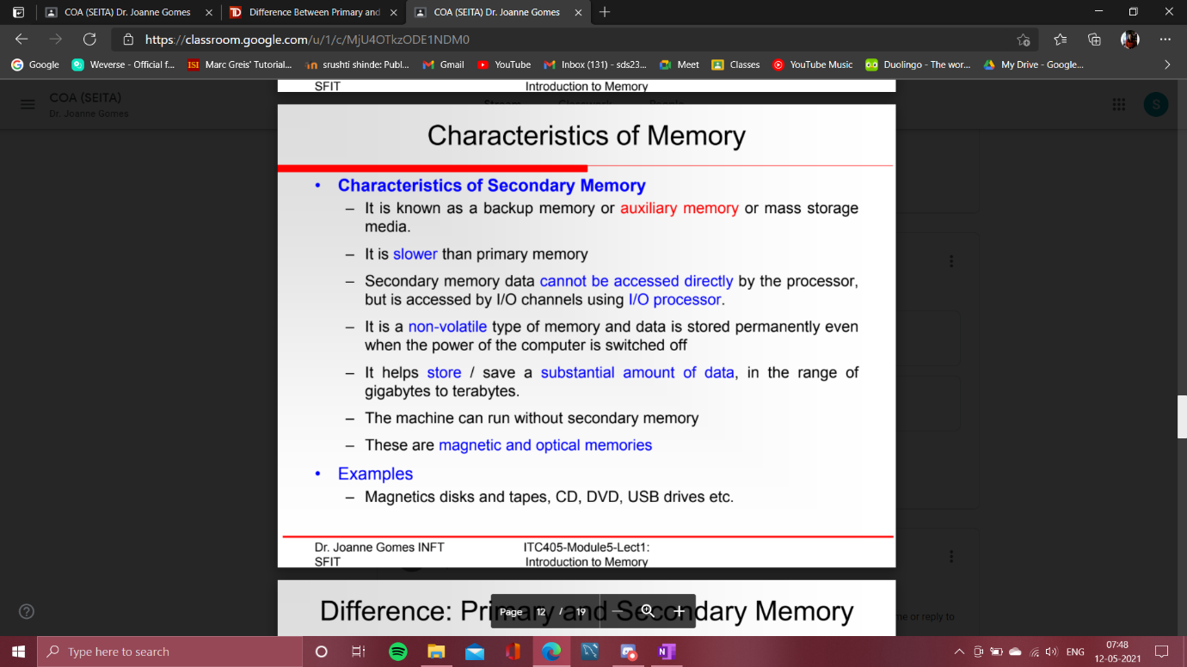

* + Types of RAM and ROM

==>

Some of the **key differences between RAM and ROM** are as follows:

|  |  |
| --- | --- |
| **RAM** | **ROM** |
| It is a temporary memory of the computer. | It is the permanent memory of the computer. |
| It is a read-write memory. The data can be written and read. | It is a read only memory. The data can only be read. |
| It is a volatile memory as it temporarily stores the files as long as the computer is on and working. | It is a non-volatile memory as it permanently stores the files even when the power is turned off, such as game cartridge and BIOS program stored in the memory of a computer, etc. |
| The storage capacity ranges from 1 to 256 GB. | Its storage capacity ranges from 4 to 8 MB. |
| It is large in size than ROM. It comes in two different sizes for use in desktop computers and laptops. A desktop ram is around 5.5 inches in length and 1 inch in width. Whereas, the Laptop RAM is around half the length of desktop RAM. | Its size ranges from less than an inch in length to multiple inches in length and width based on their use. It has less capacity than RAM. |
| Data stored in RAM can be retrieved and altered. | We can only read the data stored in ROM. It cannot be altered. |
| It is faster than ROM as it is a high-speed memory. | It is slower than the RAM. |
| The data stored in RAM is used by the CPU in real-time to run the computer. | The data stored in ROM is used by CPU only when it is transferred to RAM. |
| It temporarily stores the files and data that the CPU needs to process the current instructions or work. | It stores the BIOS program on the motherboard of a computer, which is needed to bootstrap the computer. |
| Examples: It is used as CPU Cache, Primary Memory in a computer. | Examples: It is used as Firmware by micro-controllers. |
| The stored data is easy to access. | The stored data is not as easy to access as it is in ROM. |
| It is costlier than ROM. | It is cheaper than RAM. |
| Types: DRAM (Dynamic Random Access Memory), SRAM (Static Random Access Memory). | Types: PROM (programmable read-only memory), EPROM (erasable programmable read-only memory), EEPROM( electrically erasable programmable ROM), Mask ROM. |

**Different types of RAM and ROM**

Random Access Memory (RAM) is classified into two types. They are

* + **DRAM**(Dynamic Random Access Memory) – DRAM Is commonly used as the main memory for the computer. Inside an integrated circuit, each DRAM memory cell consists of a transistor and a capacitor and a data bit is stored in the capacitor. Because transistors often leak a small amount, the condensers gradually discharge, allowing the information stored in it to drain thus, DRAM has to be refreshed every few milliseconds (given a new electronic charge) to maintain data.
  + **SRAM**(Static Random Access Memory) – SRAM is composed of 4 to 6 transistors. It holds data in the memory as long as power is supplied to the device, unlike DRAM, which needs to be regularly refreshed. As such, SRAM is more costly but quicker, making DRAM the more widespread memory in computer systems.

Read-Only Memory has three types in it. They are

* + **PROM**–PROM or programmable ROM is a computer memory chip that can be programmed once it is created. When the PROM is programmed, the written information is permanent and cannot be removed or erased.
  + **EPROM**–Erasable Programmable Read-Only Memory, EPROM is a non-volatile memory chip, developed in 1971 by Dov Frohman. When exposed to ultraviolet light, an EPROM can be reprogrammed if necessary, but otherwise no new data would be accepted or saved. Computer manufacturers use EPROM when it might be necessary to modify the data stored on the EPROM. EPROM chips are not commonly used in computers and have been replaced by EEPROM chips.
  + **EEPROM–**The EEPROM is an electrically erasable programmable read-only memory which can be erased and reprogrammed using an electrical charge. George Perlegos developed EEPROM while at Intel in 1978, and unlike most of the memory inside a computer, this memory remembers data when the power is switched off. EEPROM was a substitute for the PROM and EPROM chips and is used for the [**BIOS**](https://www.classmate4u.com/bios-basic-input-output-system/)of later computers designed after 1994. Using an EEPROM machine helps a computer user to update the BIOS on their device without the need to open the

computer or remove chips.

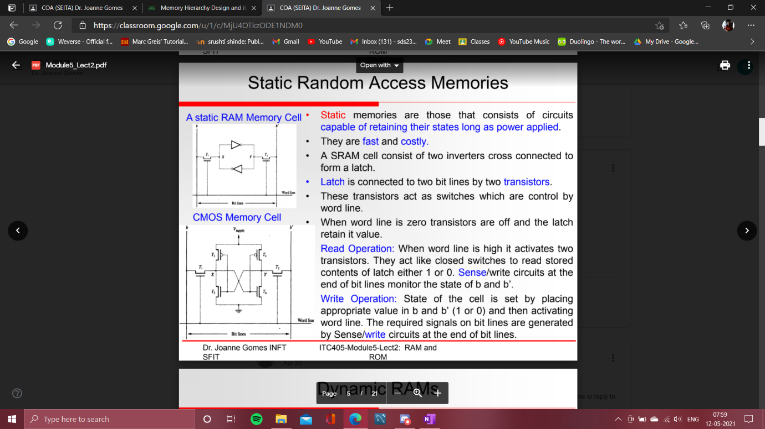

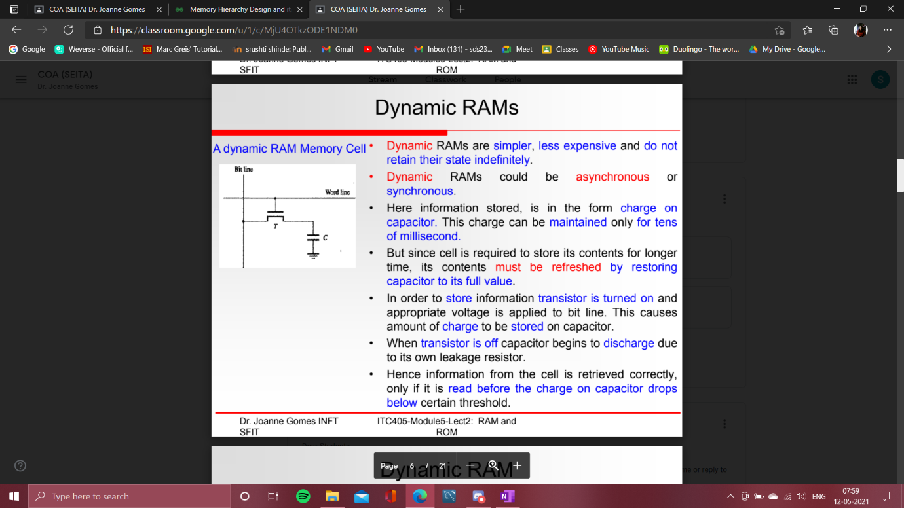

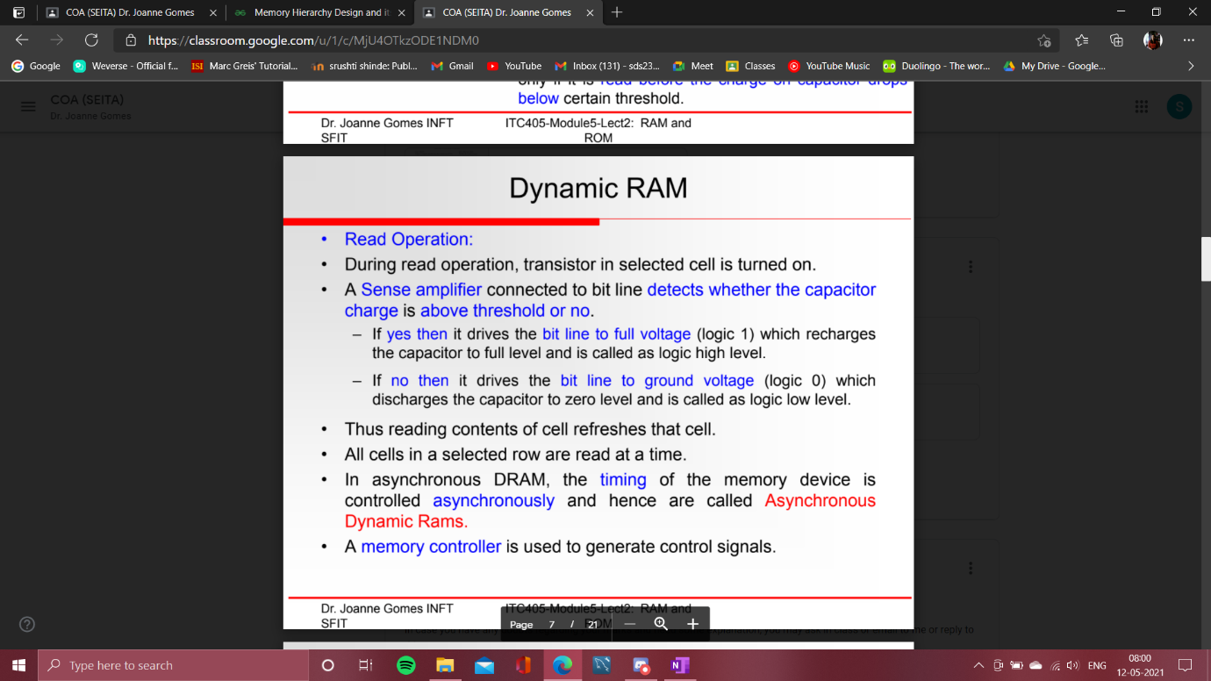

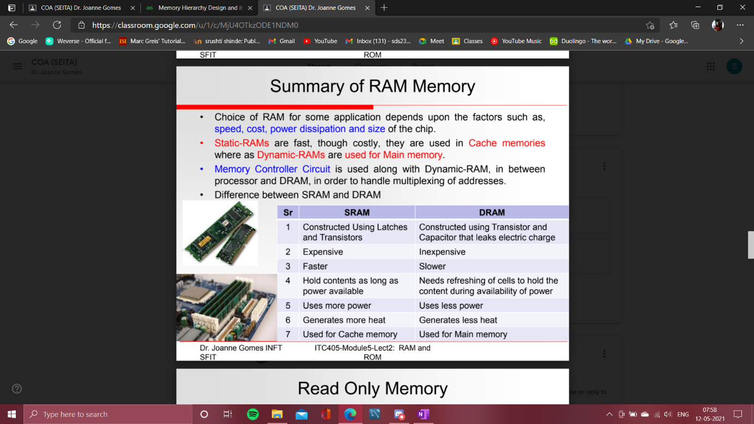

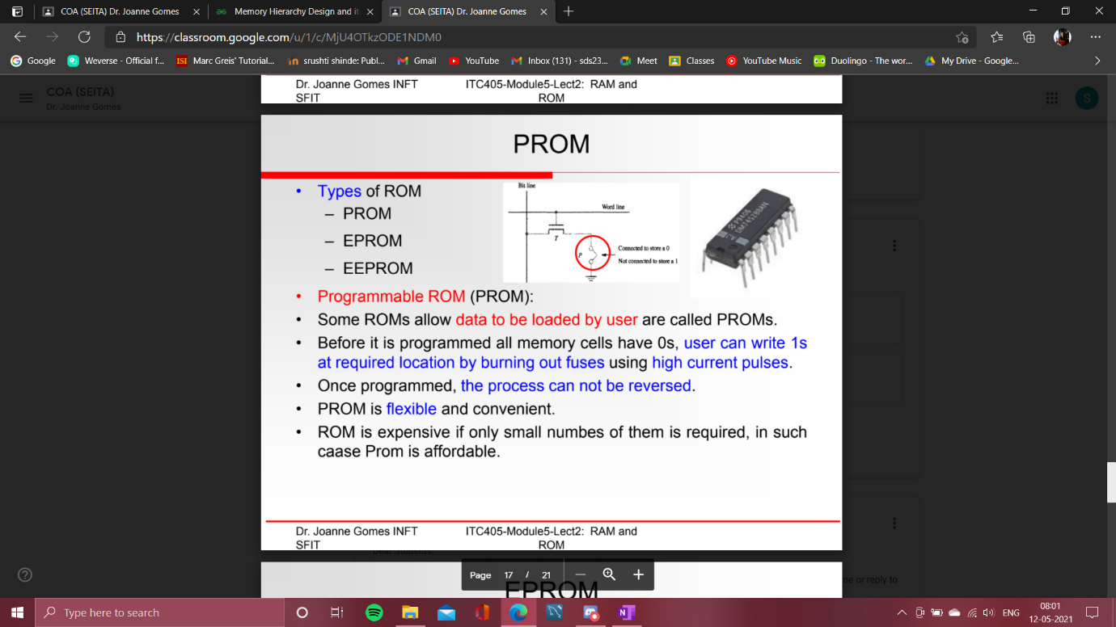

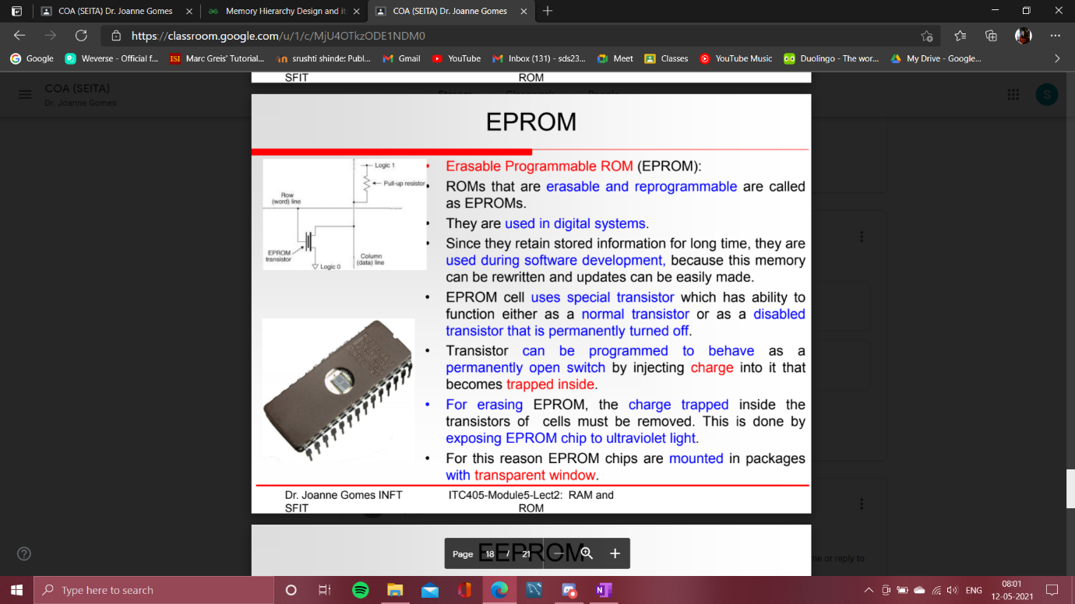

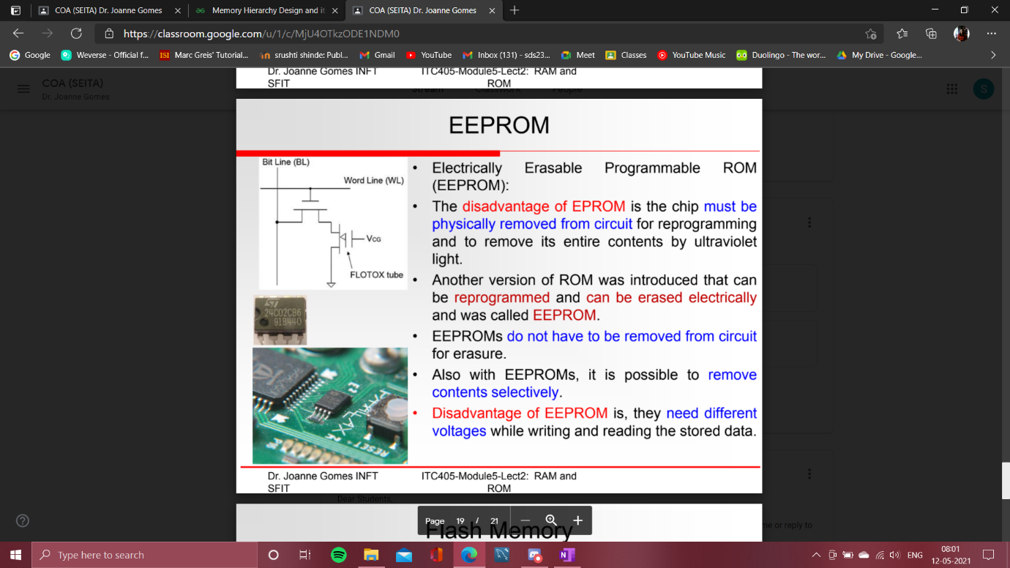

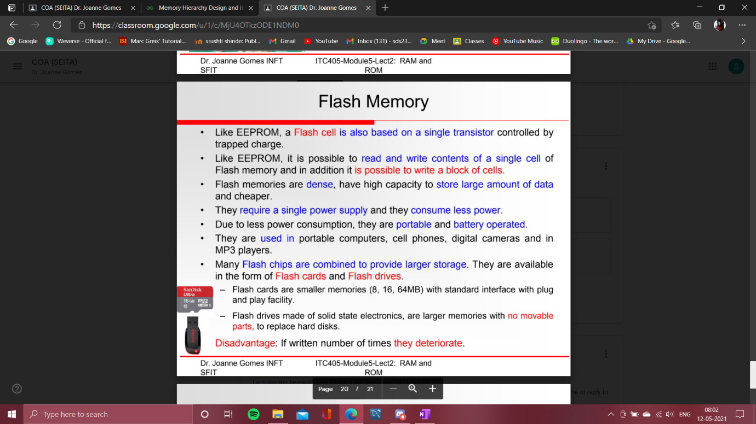

**Advantages of RAM and ROM**

Some of the advantages of RAM are –

* + It increases the computer system speed, and the higher the system speed, the greater the RAM.
  + The [CPU](https://www.classmate4u.com/central-processing-unit/)can read data quicker than the RAM. (Compared to hard disk, CD, DVD, FLOPPY, DISK, and USB)
  + There is very little use of battery life.
  + It can write and delete operations.

Some of the advantages of ROM are –

* + It is non-volatile and is cheaper than RAM
  + As they are static they do not need refreshing everytime.
  + Circuits are simple and ROM is more reliable than RAM.
  + Data can be stored permanently
  + It helps to start the computer and loads the OS.

**Disadvantages of RAM and ROM**

Some of the disadvantages of RAM are –

* + If the CPU wants to read the data from the RAM, then the data access from the registers and the cache is slow in comparison
  + RAM is volatile, i.e. it is difficult to store data forever.
  + It is expensive.
  + It has limited space.

Some of the disadvantages of ROM are –

* + ROM is read-only, cannot be modified.
  + If changes are required, it is not possible.

* + Memory hierarchy and characteristics.

==>

Memory Hierarchy Design and its Characteristics

* + Difficulty Level : [Basic](https://www.geeksforgeeks.org/basic/)
  + Last Updated : 17 Dec, 2018

In the Computer System Design, Memory Hierarchy is an enhancement to organize the memory such that it can minimize the access time. The Memory Hierarchy was developed based on a program behavior known as locality of references.The figure below clearly demonstrates the different levels of memory hierarchy :

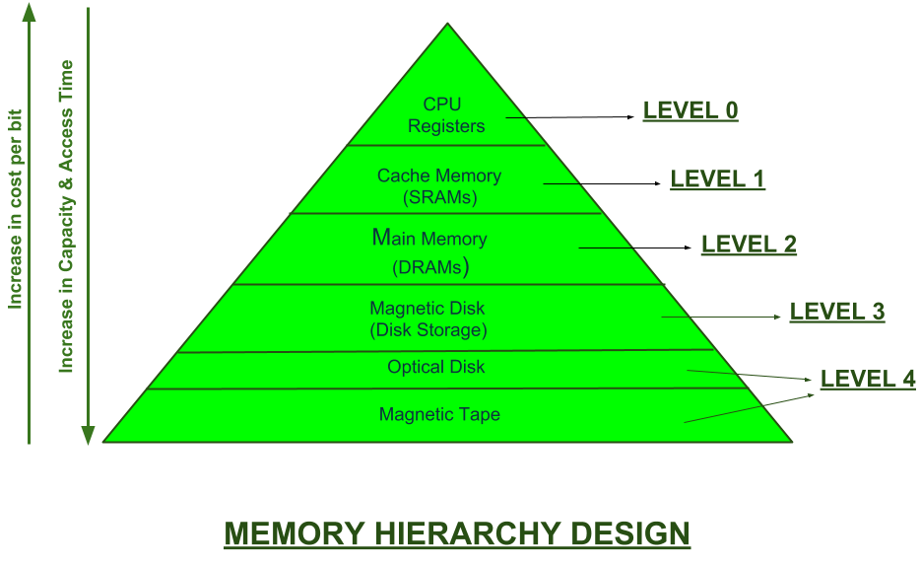

This Memory Hierarchy Design is divided into 2 main types:

* + **External Memory or Secondary Memory –**Comprising of Magnetic Disk, Optical Disk, Magnetic Tape i.e. peripheral storage devices which are accessible by the processor via I/O Module.
  + **Internal Memory or Primary Memory –**Comprising of Main Memory, Cache Memory & CPU registers. This is directly accessible by the processor.

We can infer the following characteristics of Memory Hierarchy Design from above figure:

* + **Capacity:**It is the global volume of information the memory can store. As we move from top to bottom in the Hierarchy, the capacity increases.
  + **Access Time:**It is the time interval between the read/write request and the availability of the data. As we move from top to bottom in the Hierarchy, the access time increases.
  + **Performance:**Earlier when the computer system was designed without Memory Hierarchy design, the speed gap increases between the CPU registers and Main Memory due to large difference in access time. This results in lower performance of the system and thus, enhancement was required. This enhancement was made in the form of Memory Hierarchy Design because of which the performance of the system increases. One of the most significant ways to increase system performance is minimizing how far down the memory hierarchy one has to go to manipulate data.
  + **Cost per bit:**As we move from bottom to top in the Hierarchy, the cost per bit increases i.e. Internal Memory is costlier than External Memory.

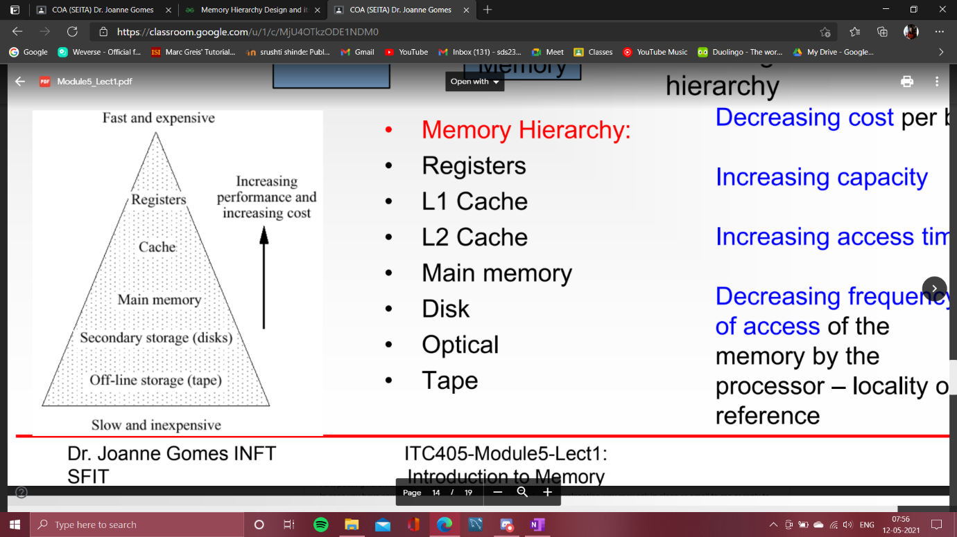

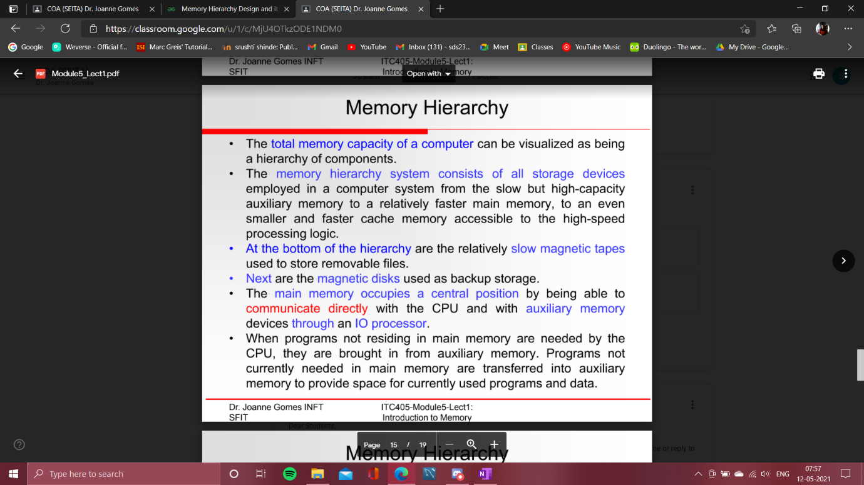

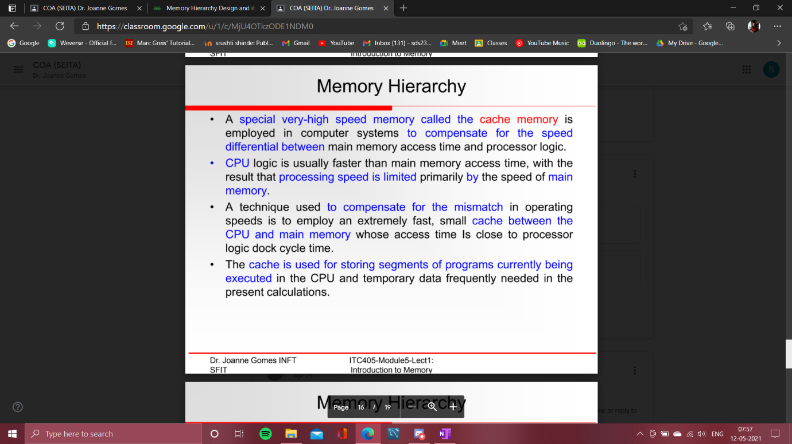

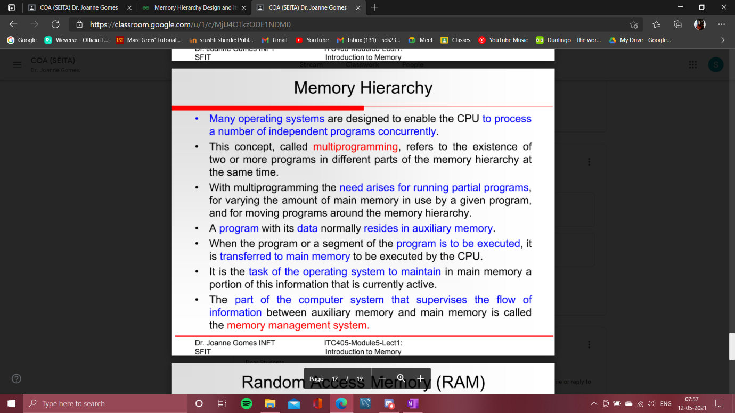

* 1. Cache memory: Concept, architecture (L1, L2, L3),

==>

Cache Memory in Computer Organization

* + Difficulty Level : [Easy](https://www.geeksforgeeks.org/easy/)
  + Last Updated : 08 Jun, 2020

**Cache Memory** is a special very high-speed memory. It is used to speed up and synchronizing with high-speed CPU. Cache memory is costlier than main memory or disk memory but economical than CPU registers. Cache memory is an extremely fast memory type that acts as a buffer between RAM and the CPU. It holds frequently requested data and instructions so that they are immediately available to the CPU when needed.

Cache memory is used to reduce the average time to access data from the Main memory. The cache is a smaller and faster memory which stores copies of the data from frequently used main memory locations. There are various different independent caches in a CPU, which store instructions and data.

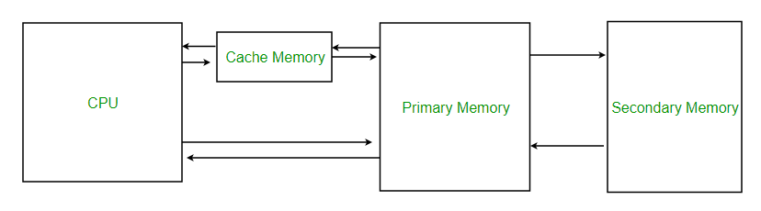

**Levels of memory:**

* + **Level 1 or Register –**It is a type of memory in which data is stored and accepted that are immediately stored in CPU. Most commonly used register is accumulator, Program counter, address register etc.
  + **Level 2 or Cache memory –**It is the fastest memory which has faster access time where data is temporarily stored for faster access.
  + **Level 3 or Main Memory –**It is memory on which computer works currently. It is small in size and once power is off data no longer stays in this memory.
  + **Level 4 or Secondary Memory –**It is external memory which is not as fast as main memory but data stays permanently in this memory.

**Cache Performance:**

When the processor needs to read or write a location in main memory, it first checks for a corresponding entry in the cache.

* + If the processor finds that the memory location is in the cache, a **cache hit** has occurred and data is read from cache
  + If the processor **does not** find the memory location in the cache, a **cache miss** has occurred. For a cache miss, the cache allocates a new entry and copies in data from main memory, then the request is fulfilled from the contents of the cache.

The performance of cache memory is frequently measured in terms of a quantity called **Hit ratio.**

Hit ratio = hit / (hit + miss) = no. of hits/total accesses

We can improve Cache performance using higher cache block size, higher associativity, reduce miss rate, reduce miss penalty, and reduce the time to hit in the cache.

**Cache Mapping:**

There are three different types of mapping used for the purpose of cache memory which are as follows: Direct mapping, Associative mapping, and Set-Associative mapping. These are explained below.

* + **Direct Mapping –**The simplest technique, known as direct mapping, maps each block of main memory into only one possible cache line. or  
    In Direct mapping, assigne each memory block to a specific line in the cache. If a line is previously taken up by a memory block when a new block needs to be loaded, the old block is trashed. An address space is split into two parts index field and a tag field. The cache is used to store the tag field whereas the rest is stored in the main memory. Direct mapping`s performance is directly proportional to the Hit ratio.  
    i = j modulo m  
    where  
    i=cache line number  
    j= main memory block number  
    m=number of lines in the cache  
    For purposes of cache access, each main memory address can be viewed as consisting of three fields. The least significant w bits identify a unique word or byte within a block of main memory. In most contemporary machines, the address is at the byte level. The remaining s bits specify one of the 2s blocks of main memory. The cache logic interprets these s bits as a tag of s-r bits (most significant portion) and a line field of r bits. This latter field identifies one of the m=2r lines of the cache.

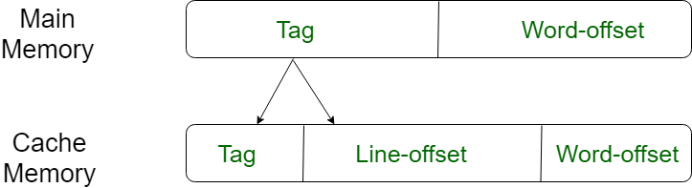

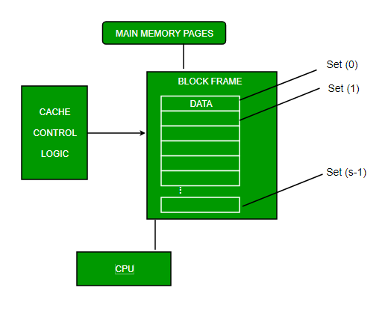

* 1. **Associative Mapping –**In this type of mapping, the associative memory is used to store content and addresses of the memory word. Any block can go into any line of the cache. This means that the word id bits are used to identify which word in the block is needed, but the tag becomes all of the remaining bits. This enables the placement of any word at any place in the cache memory. It is considered to be the fastest and the most flexible mapping form.

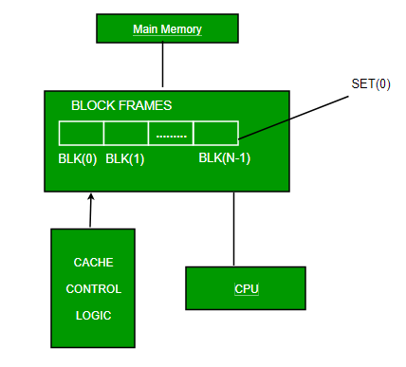

* 1. **Set-associative Mapping –**This form of mapping is an enhanced form of direct mapping where the drawbacks of direct mapping are removed. Set associative addresses the problem of possible thrashing in the direct mapping method. It does this by saying that instead of having exactly one line that a block can map to in the cache, we will group a few lines together creating a ***set***. Then a block in memory can map to any one of the lines of a specific set..Set-associative mapping allows that each word that is present in the cache can have two or more words in the main memory for the same index address. Set associative cache mapping combines the best of direct and associative cache mapping techniques.  
     In this case, the cache consists of a number of sets, each of which consists of a number of lines. The relationships are  
     m = v * k  
     i= j mod v  
       
     where  
     i=cache set number  
     j=main memory block number  
     v=number of sets  
     m=number of lines in the cache number of sets   
     k=number of lines in each set

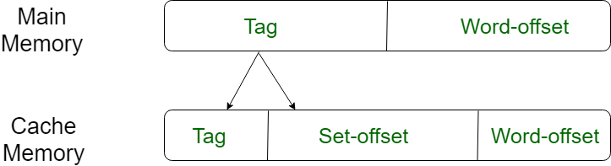

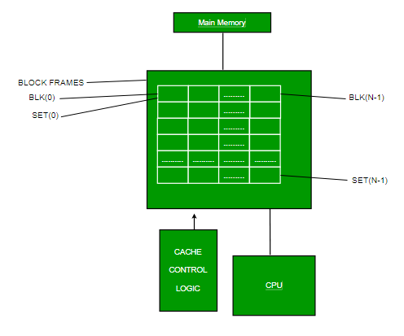

**Application of Cache Memory –**

* 1. Usually, the cache memory can store a reasonable number of blocks at any given time, but this number is small compared to the total number of blocks in the main memory.
  2. The correspondence between the main memory blocks and those in the cache is specified by a mapping function.  
       
       
       
     **Types of Cache –**
  + **Primary Cache –**A primary cache is always located on the processor chip. This cache is small and its access time is comparable to that of processor registers.
  + **Secondary Cache –**Secondary cache is placed between the primary cache and the rest of the memory. It is referred to as the level 2 (L2) cache. Often, the Level 2 cache is also housed on the processor chip.  
      
      
      
    **Locality of reference –**Since size of cache memory is less as compared to main memory. So to check which part of main memory should be given priority and loaded in cache is decided based on locality of reference.  
    **Types of Locality of reference**
  + **Spatial Locality of reference**This says that there is a chance that element will be present in the close proximity to the reference point and next time if again searched then more close proximity to the point of reference.
  + **Temporal Locality of reference**In this Least recently used algorithm will be used. Whenever there is page fault occurs within a word will not only load word in main memory but complete page fault will be loaded because spatial locality of reference rule says that if you are referring any word next word will be referred in its register that’s why we load complete page table so the complete block will be loaded.

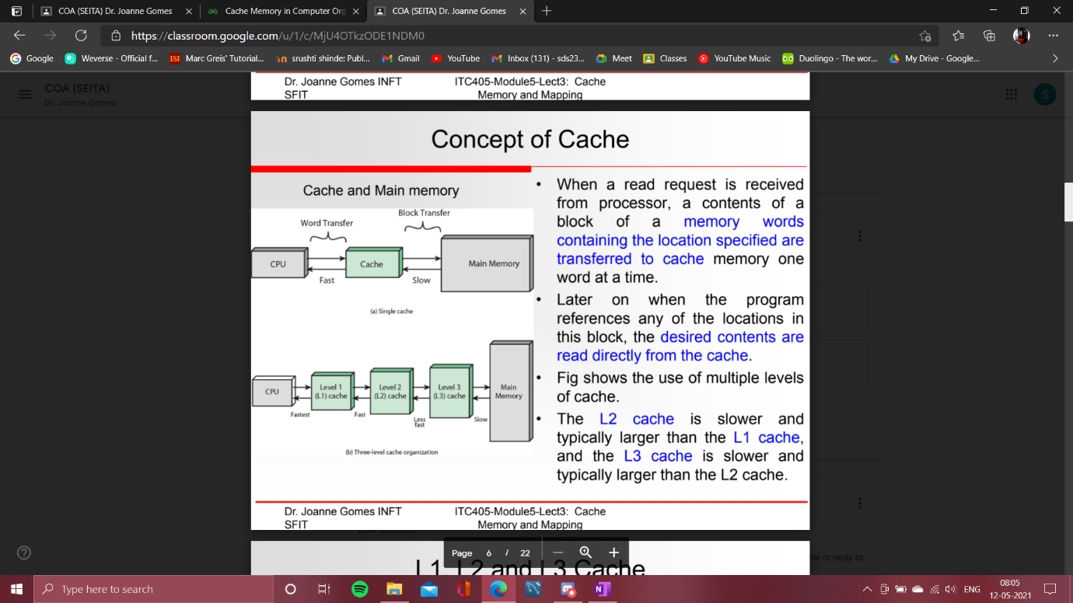

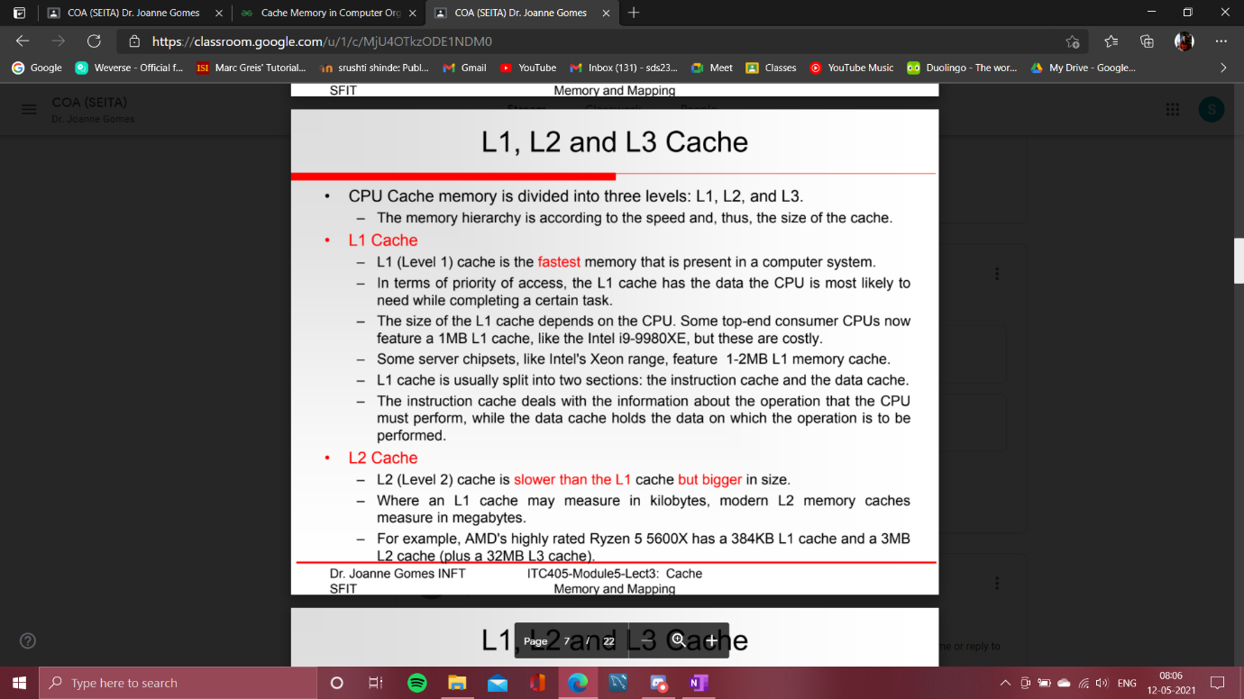

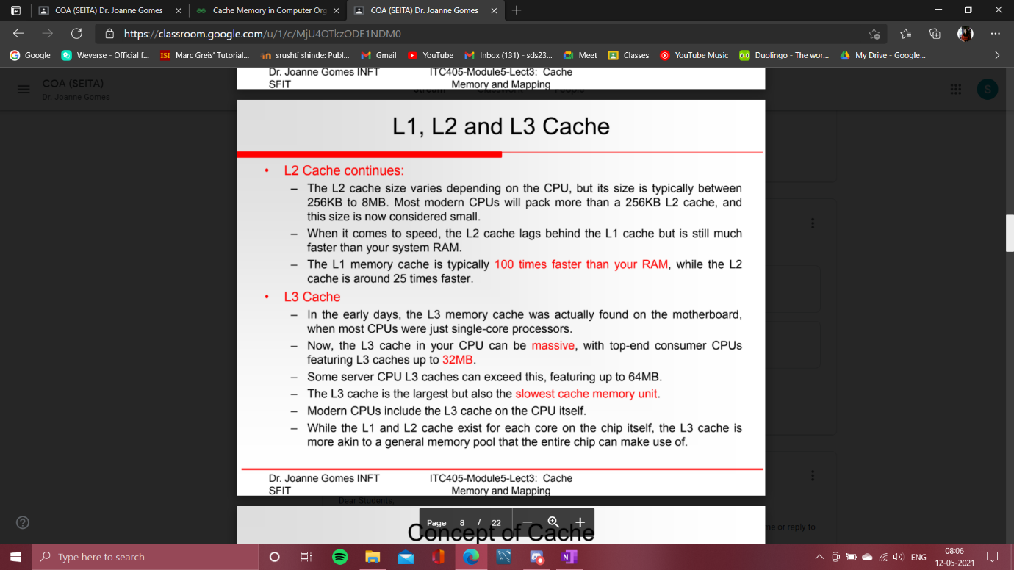

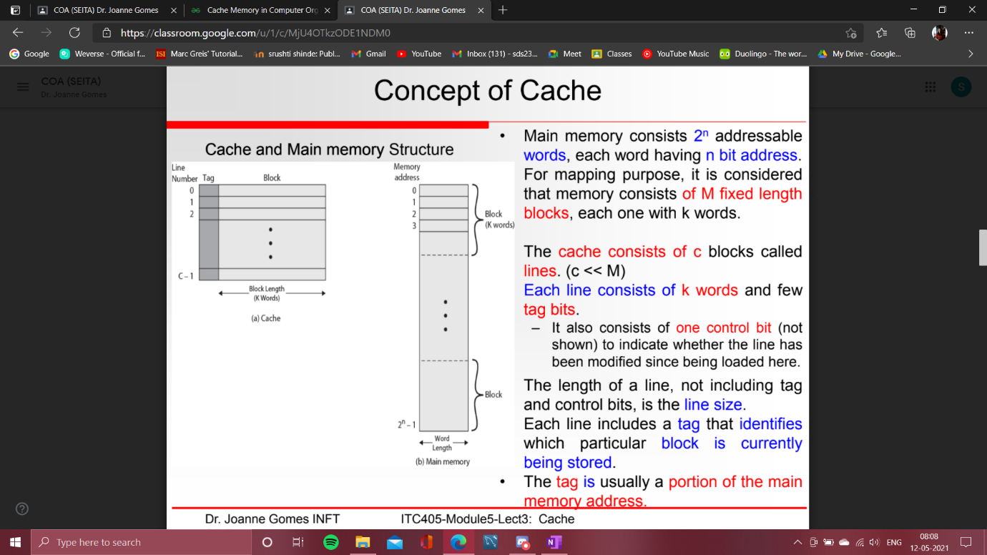

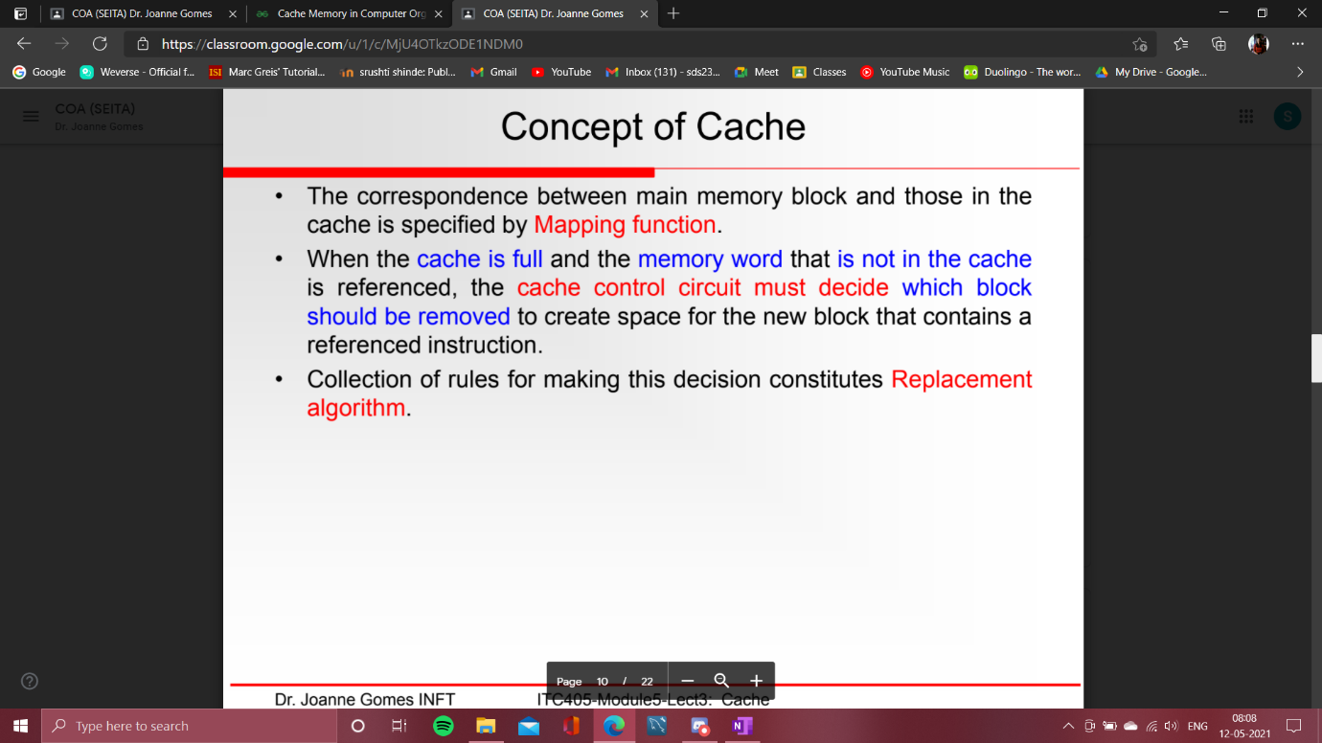

* 1. CACHE READ OPERATION

==>

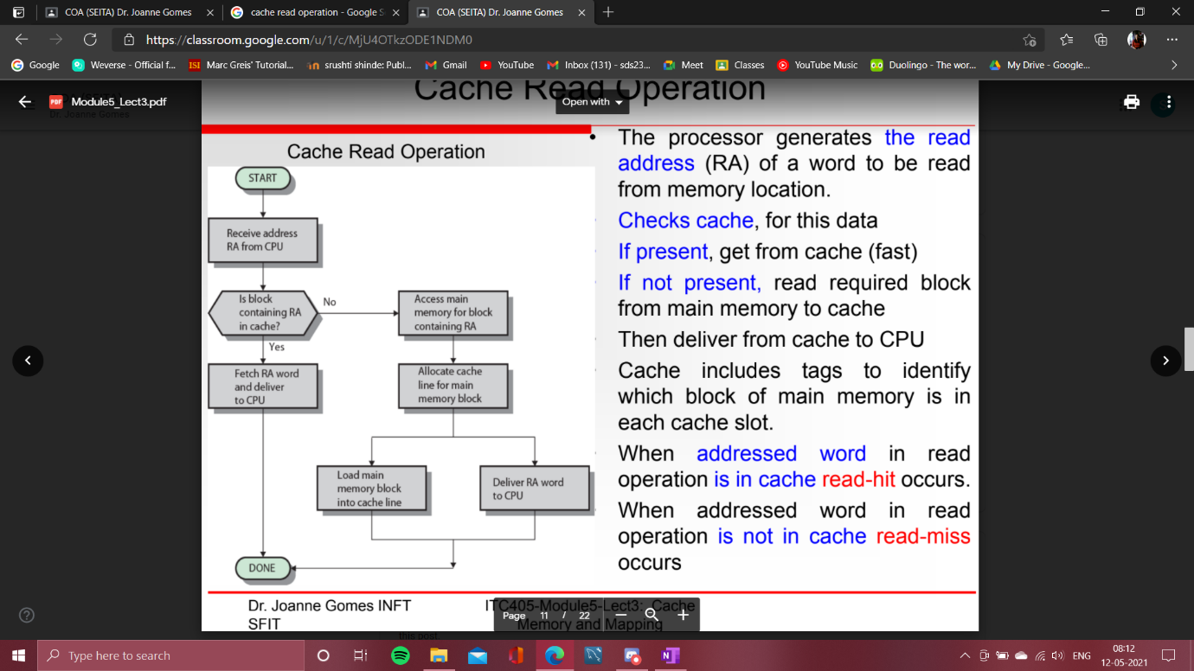

* 1. CACHE ORGANIZATION

=>

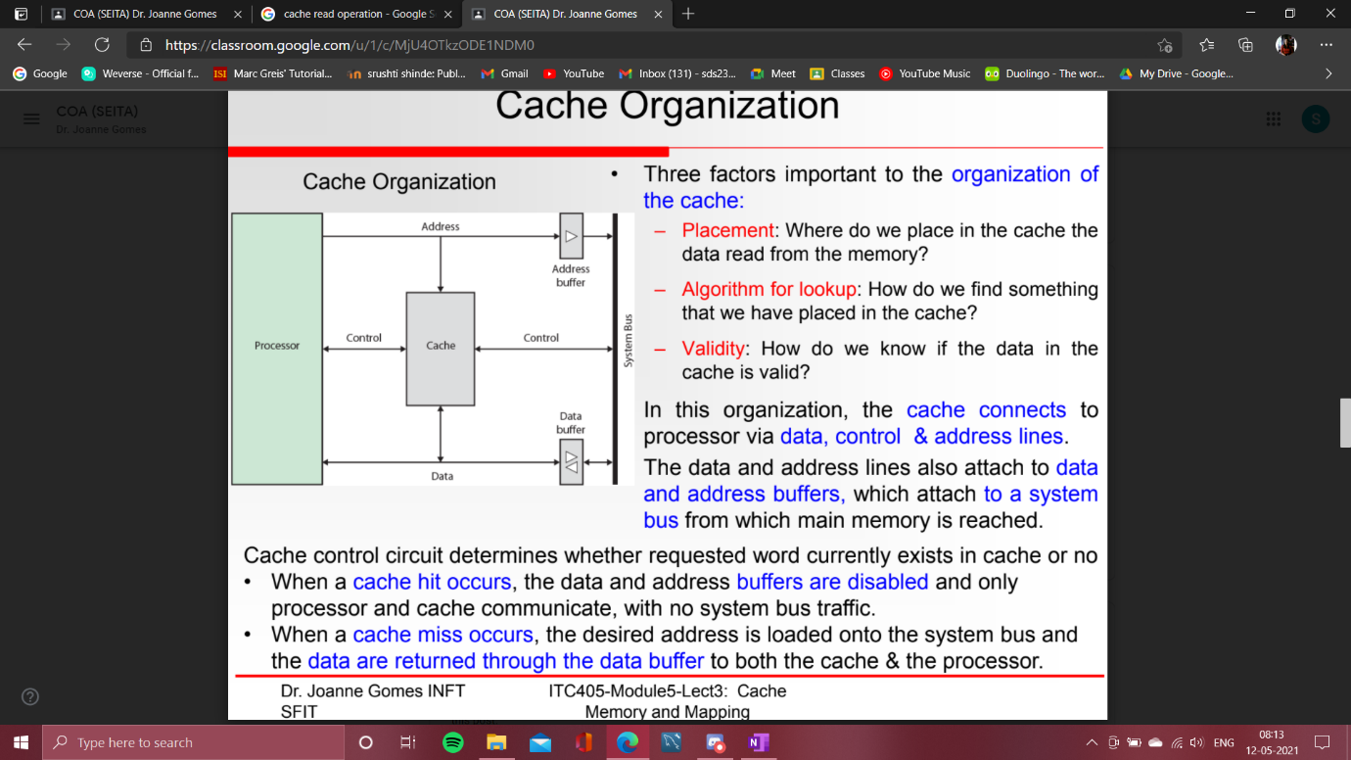

* 1. CACHE DESIGN

=>

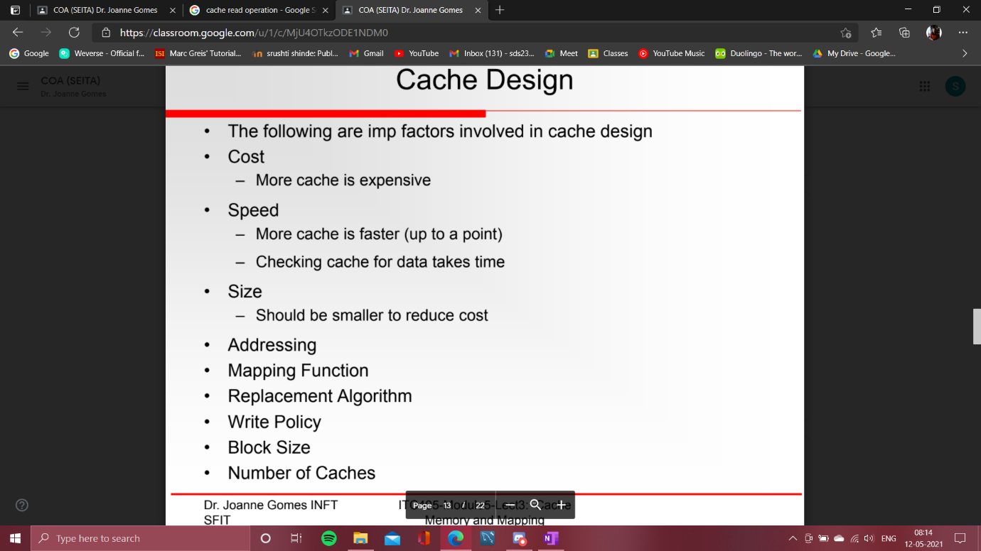

* 1. CACHE ADDRESSING

=>

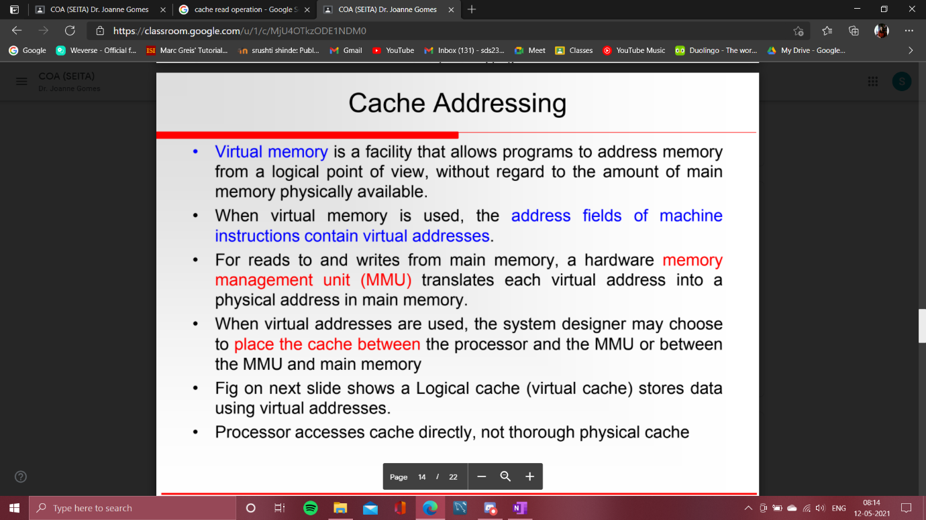

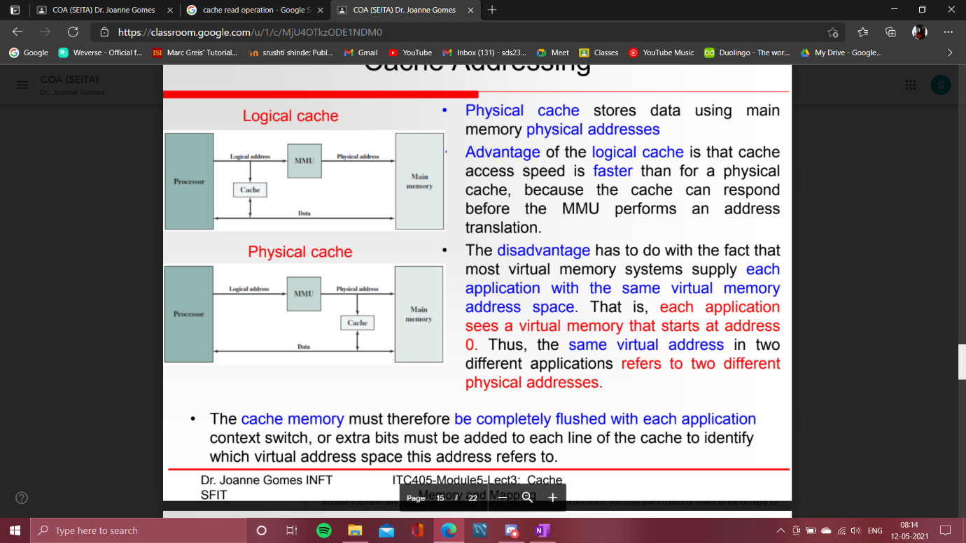

* 1. MAPPING TECHNIQUES

=>

Mapping techniques

The process of transfer the data from main memory to cache memory is called as mapping. In the cache memory, there are three kinds of **mapping techniques** are used.

* 1. Associative mapping
  2. Direct mapping
  3. Set Associative mapping

**Components present in each line are:**

* 1. **Valid bit:** This gives the status of the data block. If 0 then the data block is not referenced and if 1 then the data block is referenced.
  2. **Tag:** This is the main memory address part.
  3. **Data:** This is the data block.

1) Associative mapping

In this technique, a number of mapping functions are used to transfer the data from main memory to cache memory. That means any main memory can be mapped into any cache line. Therefore, cache memory address is not in the use. Associative cache controller interprets the request by using the main memory address format. During the mapping process, the complete data block is transferred to cache memory along with the complete tags.

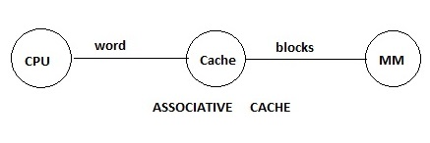

* 1. Associative cache controller interprets the CPU generated request as:

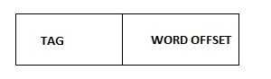

* 1. The existing tag in the cache controller compared with the CPU generated tags.
  2. If anyone of the tag in the matching operation becomes hit. So, based on the word offset the respective data is transfer to CPU.
  3. If none of the tags are matching operation become miss. So, the references will be forwarded to the main memory.
  4. According to the main memory address format, the respective main memory block is enabled then transferred to the cache memory by using the associative mapping. Later the data will be transfer to the CPU.
  5. In this mapping technique, replacement algorithms are used to replace the cache block when the cache is full.
  6. Tag memory size = number of lines * number of tag bits in the line.

**Tag memory size = 4*3 bits**

**Tag memory size = 12 bits**

2) Direct mapping

In this mapping technique, the mapping function is used to transfer the data from main memory to cache memory. The mapping function is:

K mod N = i

**Where,**

* 1. K is the main memory block number.
  2. N is the number of cache lines.
  3. And, i is the cache memory line number.

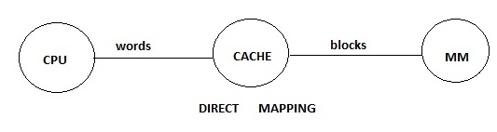

* 1. Direct cache controller interprets the CPU generated a request as:

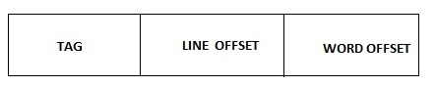

* 1. Line offset is directly connected to the address logic of the cache memory. Therefore the corresponding cache line is enabled.
  2. Existing tag in the enabled cache line is compared with the CPU generated the tag.
  3. If both are matching operation then it becomes hit. So, the respective data is transfer to CPU based on the word offset.
  4. If both are not matching operation then it becomes a miss. So, the reference is forward into the main memory.
  5. According to the main memory address format, the corresponding block is enabled, then transferred to the cache memory by using the direct mapping function. Later the data is transfer to the CPU based on the word offset.
  6. In this mapping technique, a replacement algorithm is not required because the mapping function itself replaces the blocks.
  7. The disadvantage of direct mapping is each cache line is able to hold only one block at a time. Therefore. The number of conflicts misses will be increased.
  8. To avoid the disadvantage of the direct mapping, use the alternative cache organization in which each line is able to hold more than one tags at a time. This alternative organization is called as a set associative cache organization.
  9. Tag memory size = number of lines * number of tag bits in the line.

**Tag memory size = 4*1 bits**

**Tag memory size =4 bits**

3) Set Associative Mapping

In this mapping technique, the mapping function is used to transfer the data from main memory to cache memory. The mapping function is:

K mod S = i

**Where,**

* 1. K is the main memory block number,
  2. S is the number of cache sets,
  3. And, i is the cache memory set number.

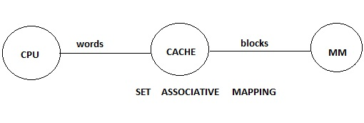

* 1. Set associative cache controller interprets the CPU generated a request as:

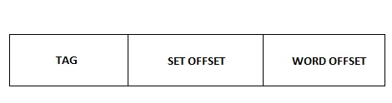

* 1. A set offset is directly connected to the address logic of the cache memory. So, respective sets will be enabled.
  2. Set contain multiple blocks so to identify the hit block there is a need of multiplexer to compare existing tags in the enabled set one after the another based on the selection bit with the CPU generated a tag.
  3. If anyone is matching, the operation becomes hit. So, the data is transfer to the CPU. If none of them is matching, then operation becomes a miss. So, the reference is forward to the CPU.
  4. The main memory block is transferred to the cache memory by using a set associative mapping function. Later data is transfer to CPU.
  5. In this technique, replacement algorithms are used to replace the blocks in the cache line, when the set is full.
  6. Tag memory size = number of sets in cache * number of blocks in the set * tag bit.

**Tag memory size = 2 * 2 * 2 bits.**

**Tag memory size = 8 bits.**

* 1. REPLACEMENT POLICIES

**=>**

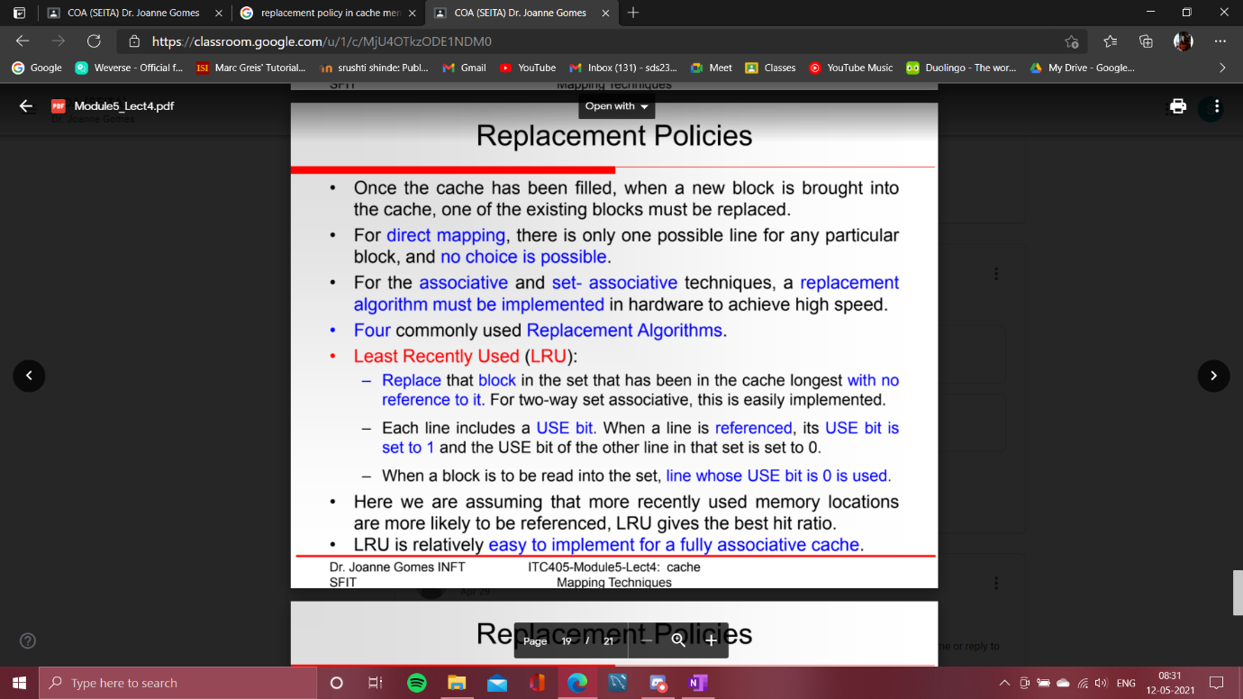

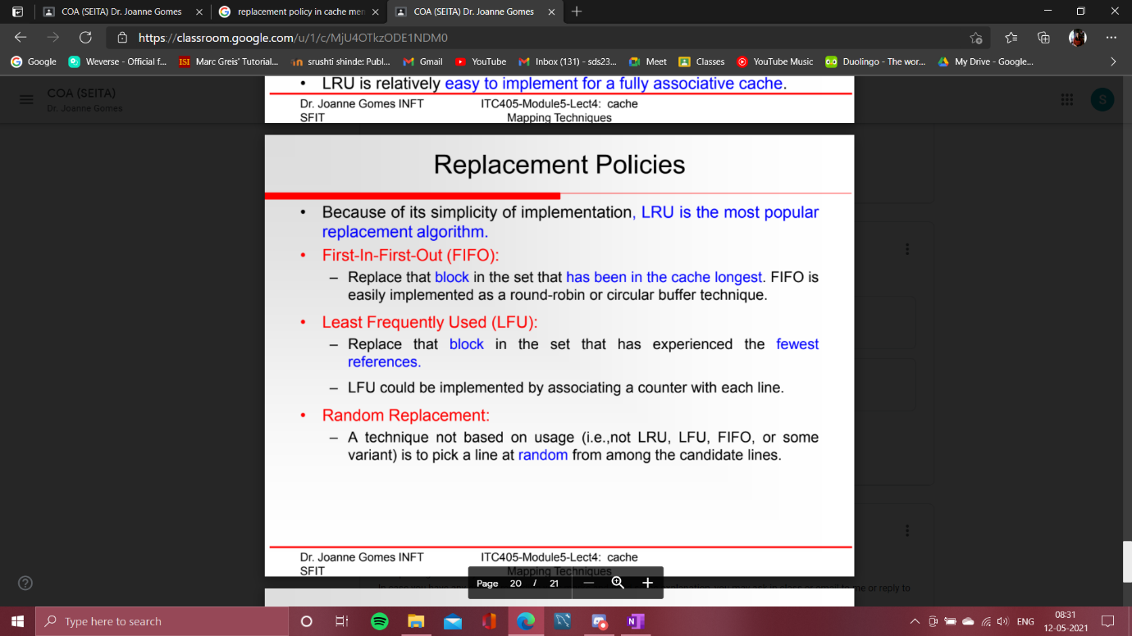

**Page Replacement-**

|  |
| --- |
| Page replacement is a process of swapping out an existing page from the frame of a main memory and replacing it with the required page. |

Page replacement is required when-

* + All the frames of main memory are already occupied.
  + Thus, a page has to be replaced to create a room for the required page.

**Page Replacement Algorithms-**

Page replacement algorithms help to decide which page must be swapped out from the main memory to create a room for the incoming page.

Various page replacement algorithms are-

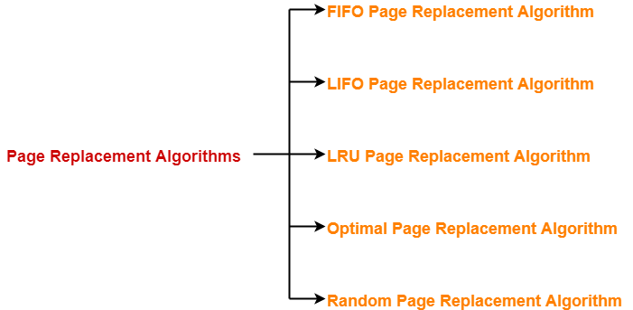

* + FIFO Page Replacement Algorithm
  + LIFO Page Replacement Algorithm
  + LRU Page Replacement Algorithm
  + Optimal Page Replacement Algorithm
  + Random Page Replacement Algorithm

|  |
| --- |
| A good page replacement algorithm is one that minimizes the number of page faults. |

**FIFO Page Replacement Algorithm-**

* + As the name suggests, this algorithm works on the principle of “**First in First out**“.
  + It replaces the oldest page that has been present in the main memory for the longest time.
  + It is implemented by keeping track of all the pages in a queue.

**LIFO Page Replacement Algorithm-**

* + As the name suggests, this algorithm works on the principle of “**Last in First out**“.
  + It replaces the newest page that arrived at last in the main memory.
  + It is implemented by keeping track of all the pages in a stack.

|  |
| --- |
| **NOTE**  Only frame is used for page replacement during entire procedure after all the frames get occupied. |

**LRU Page Replacement Algorithm-**

* + As the name suggests, this algorithm works on the principle of “**Least Recently Used**“.
  + It replaces the page that has not been referred by the CPU for the longest time.

**Optimal Page Replacement Algorithm-**

* + This algorithm replaces the page that will not be referred by the CPU in future for the longest time.
  + It is practically impossible to implement this algorithm.
  + This is because the pages that will not be used in future for the longest time can not be predicted.
  + However, it is the best known algorithm and gives the least number of page faults.
  + Hence, it is used as a performance measure criterion for other algorithms.

**Random Page Replacement Algorithm-**

* + As the name suggests, this algorithm randomly replaces any page.
  + So, this algorithm may behave like any other algorithm like FIFO, LIFO, LRU, Optimal etc
  + CACHE COHERENCE

=>

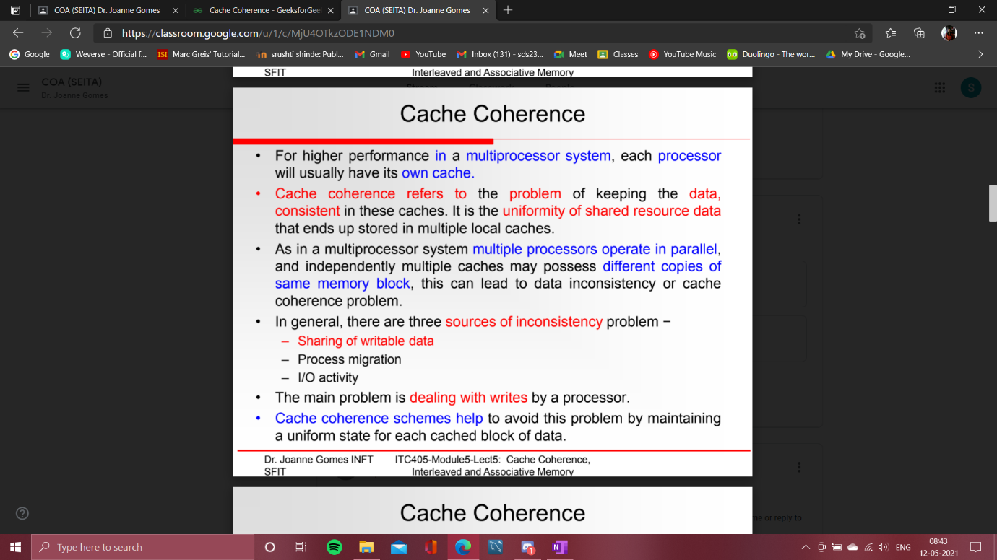

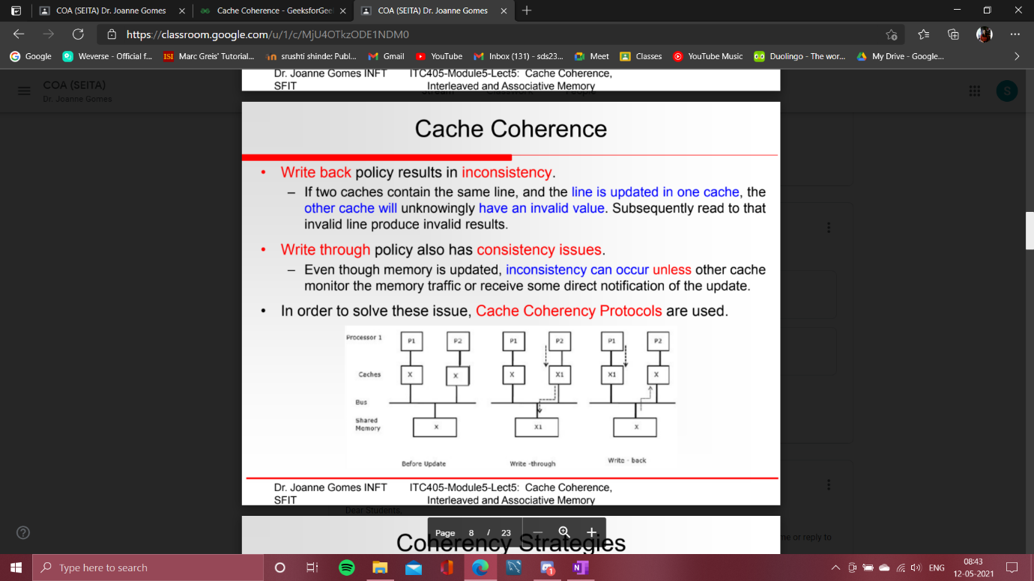







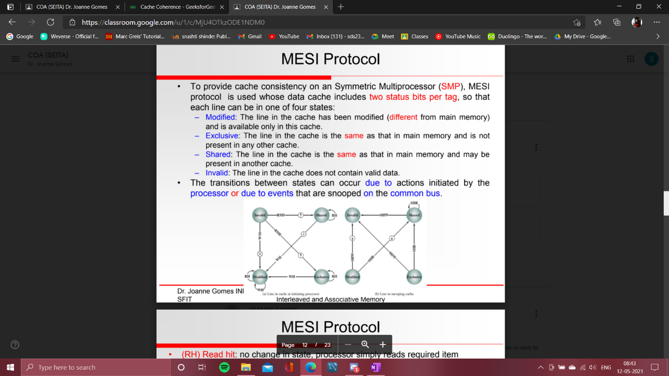

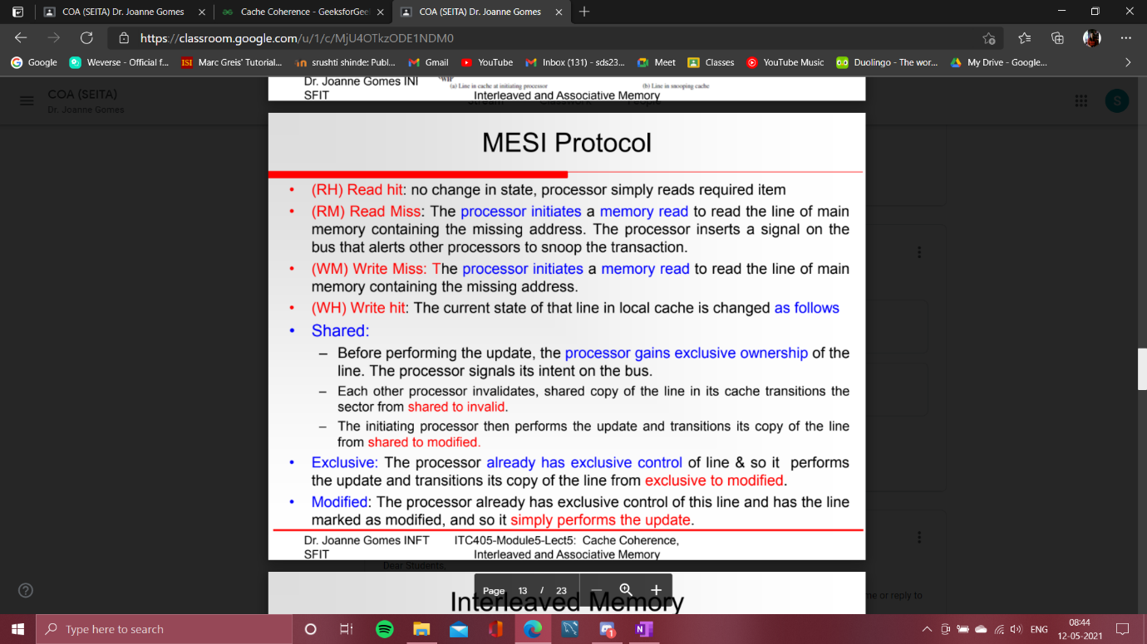

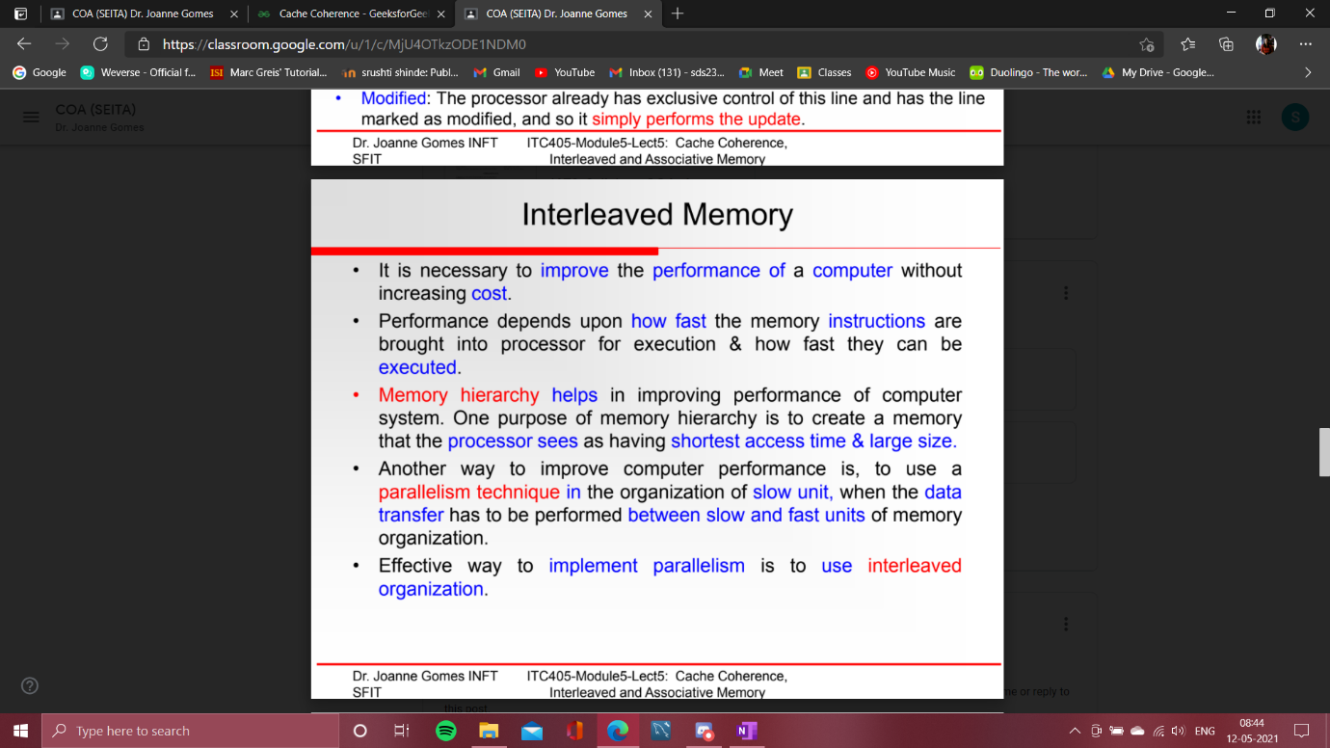

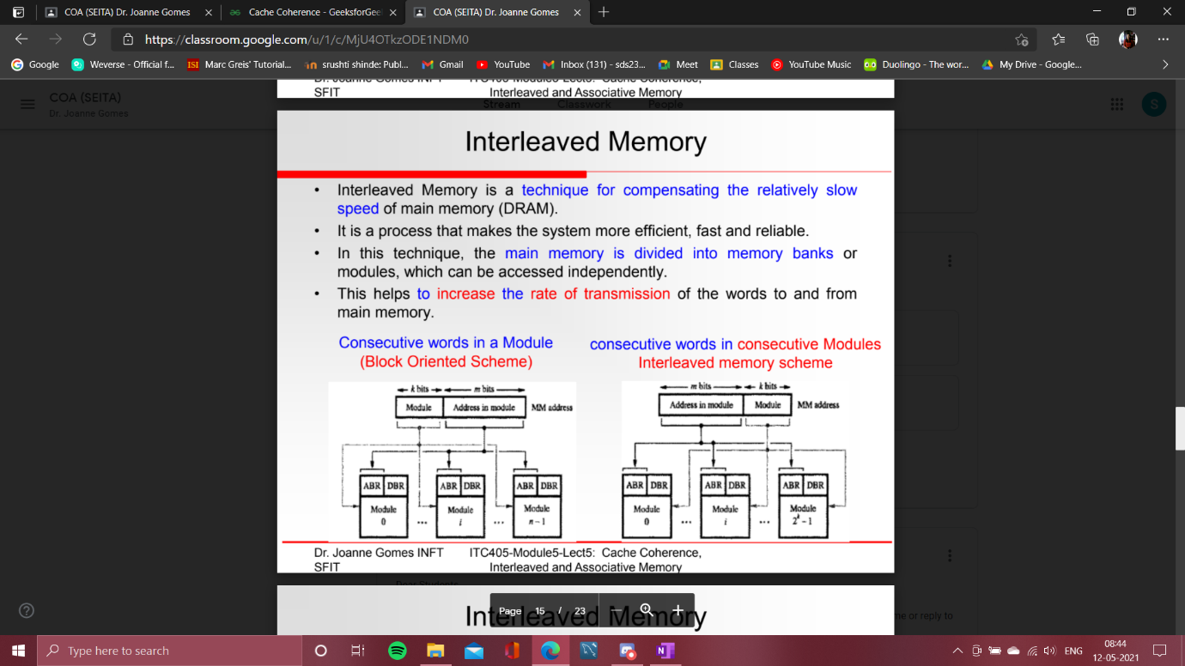

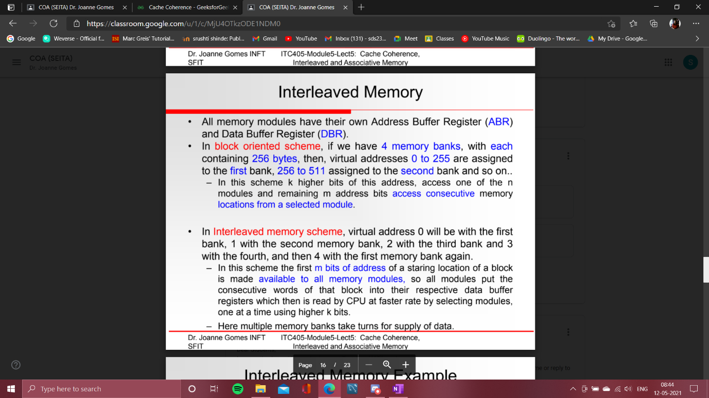

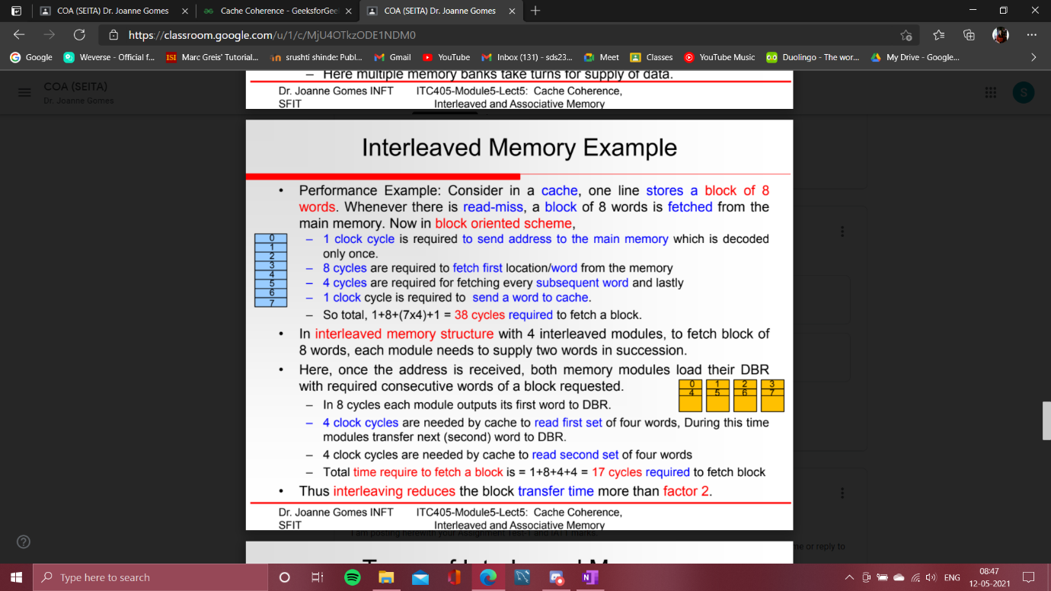

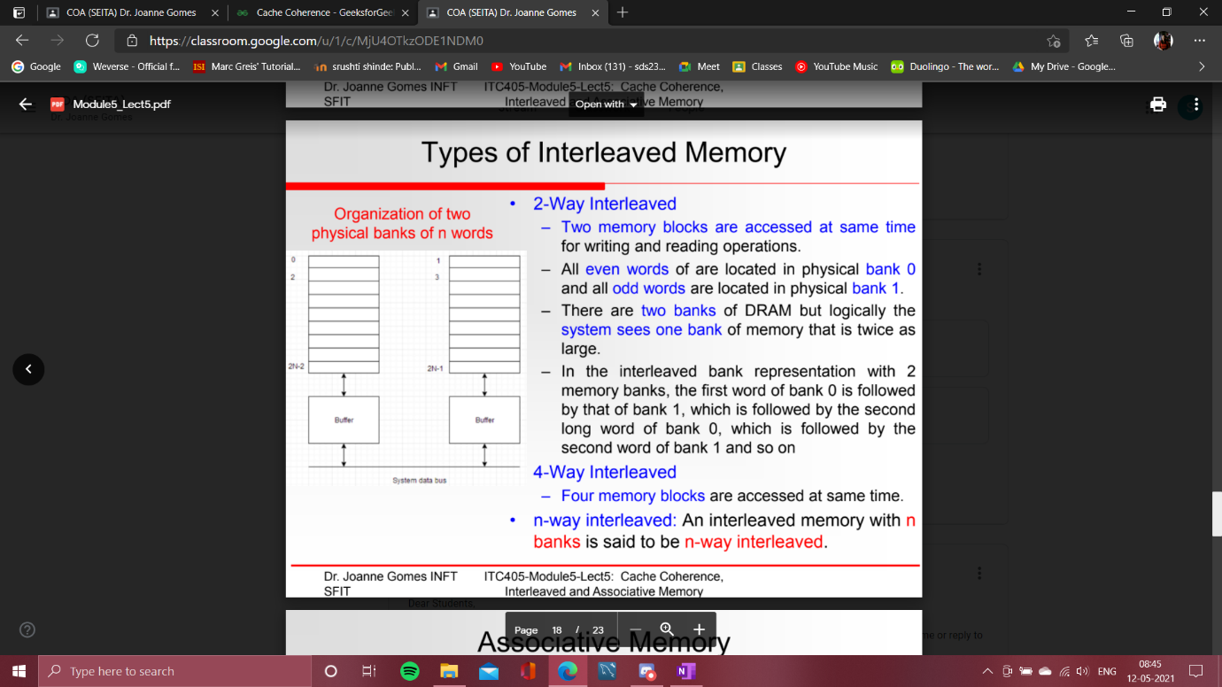

Cache Coherence

* + Last Updated : 24 Aug, 2020

Prerequisite – [Cache Memory](https://www.geeksforgeeks.org/cache-memory-in-computer-organization/)

**Cache coherence :**

In a multiprocessor system, data inconsistency may occur among adjacent levels or within the same level of the memory hierarchy.

In a shared memory multiprocessor with a separate cache memory for each processor, it is possible to have many copies of any one instruction operand: one copy in the main memory and one in each cache memory. When one copy of an operand is changed, the other copies of the operand must be changed also.

**Example :**

Cache and the main memory may have inconsistent copies of the same object.

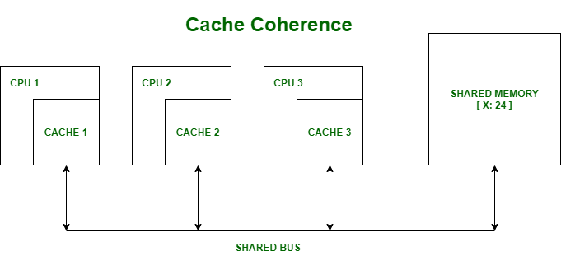

Suppose there are three processors, each having cache. Suppose the following scenario:-

* + **Processor 1 read X :** obtains 24 from the memory and caches it.
  + **Processor 2 read X :** obtains 24 from memory and caches it.
  + **Again, processor 1 writes as X :** 64, Its locally cached copy is updated. Now, processor 3 reads X, what value should it get?
  + Memory and processor 2 thinks it is 24 and processor 1 thinks it is 64.

As multiple processors operate in parallel, and independently multiple caches may possess different copies of the same memory block, this creates a cache coherence problem.

Cache coherence is the discipline that ensures that changes in the values of shared operands are propagated throughout the system in a timely fashion.

There are three distinct level of cache coherence :-

* + Every write operation appears to occur instantaneously.
  + All processors see exactly the same sequence of changes of values for each separate operand.
  + Different processors may see an operation and assume different sequences of values; this is known as non-coherent behavior.

There are various Cache Coherence Protocols in multiprocessor system. These are :-

* 1. MSI protocol (Modified, Shared, Invalid)
  2. MOSI protocol (Modified, Owned, Shared, Invalid)
  3. MESI protocol (Modified, Exclusive, Shared, Invalid)
  4. MOESI protocol (Modified, Owned, Exclusive, Shared, Invalid)

These important terms are discussed as follows:

* + **Modified –**It means that the the value in the cache is dirty, that is the value in current cache is different from the main memory.
  + **Exclusive –**It means that the value present in the cache is same as that present in the main memory, that is the value is clean.
  + **Shared –**It means that the cache value holds the most recent data copy and that is what shared among all the cache and main memory as well.
  + **Owned –**It means that the current cache holds the block and is now the owner of that block, that is having all rights on that particular blocks.
  + **Invalid –**This states that the current cache block itself is invalid and is required to be fetched from other cache or main memory.

For detail on above protocol, refer :- [Cache coherence protocol](https://www.geeksforgeeks.org/cache-coherence-protocols-in-multiprocessor-system/)

**Coherency mechanisms :**

There are three types of coherence :

* + **Directory-based –**In a directory-based system, the data being shared is placed in a common directory that maintains the coherence between caches. The directory acts as a filter through which the processor must ask permission to load an entry from the primary memory to its cache. When an entry is changed, the directory either updates or invalidates the other caches with that entry.
  + **Snooping –**First introduced in 1983, snooping is a process where the individual caches monitor address lines for accesses to memory locations that they have cached. It is called a write invalidate protocol. When a write operation is observed to a location that a cache has a copy of and the cache controller invalidates its own copy of the snooped memory location.
  + **Snarfing –**It is a mechanism where a cache controller watches both address and data in an attempt to update its own copy of a memory location when a second master modifies a location in main memory. When a write operation is observed to a location that a cache has a copy of the cache controller updates its own copy of the snarfed memory location with the new data.

* 1. Associative Memory

=>

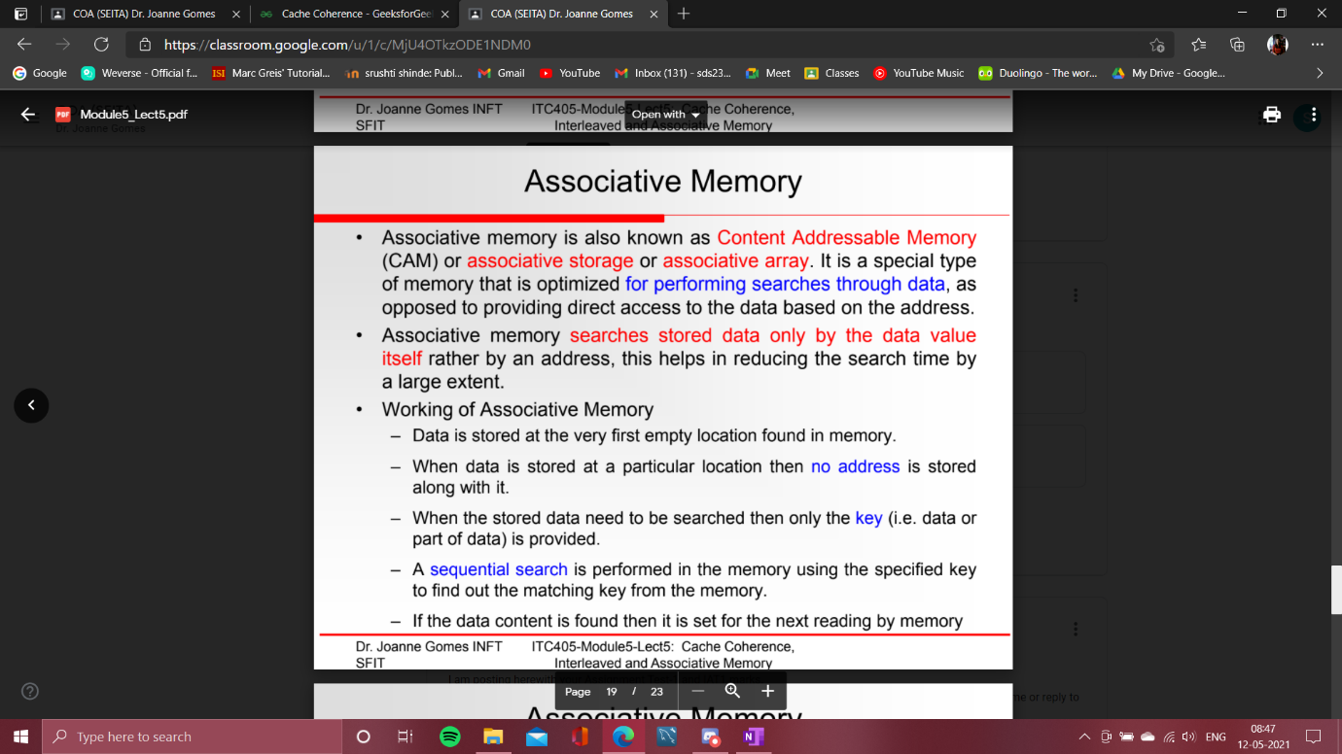

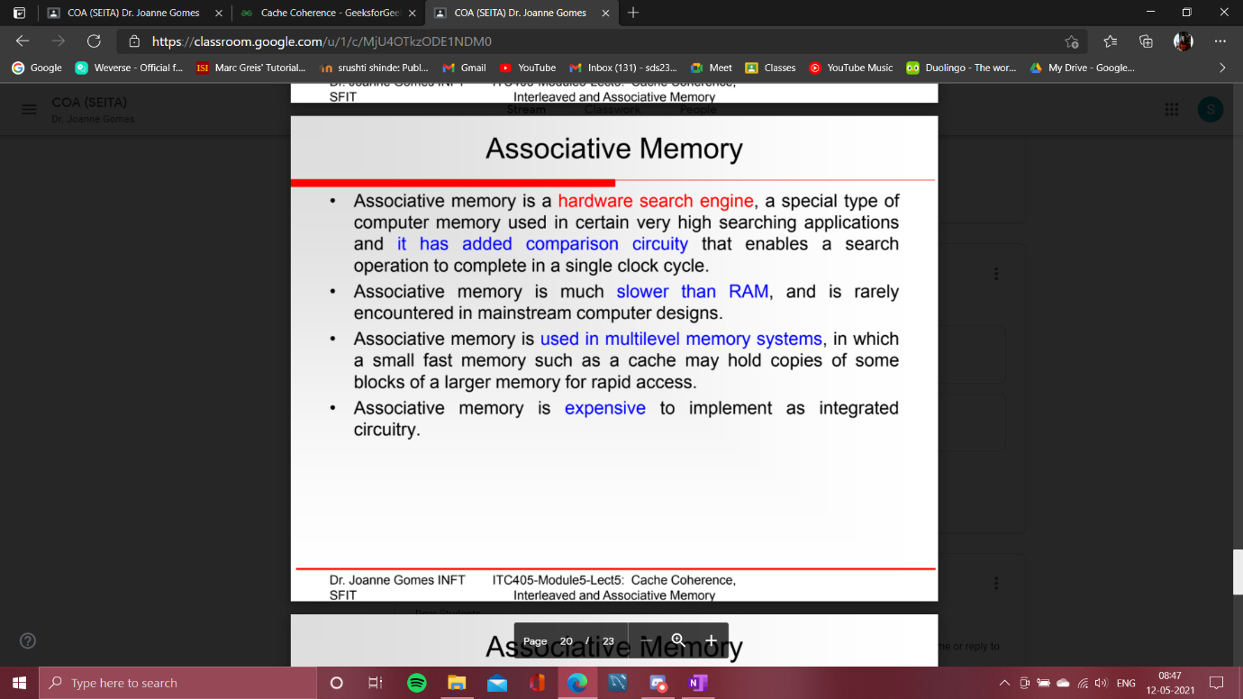

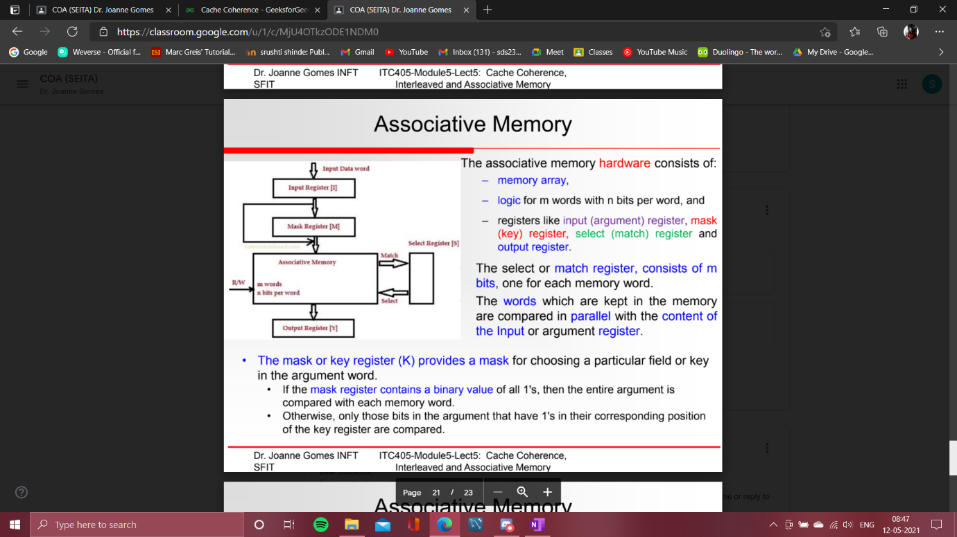

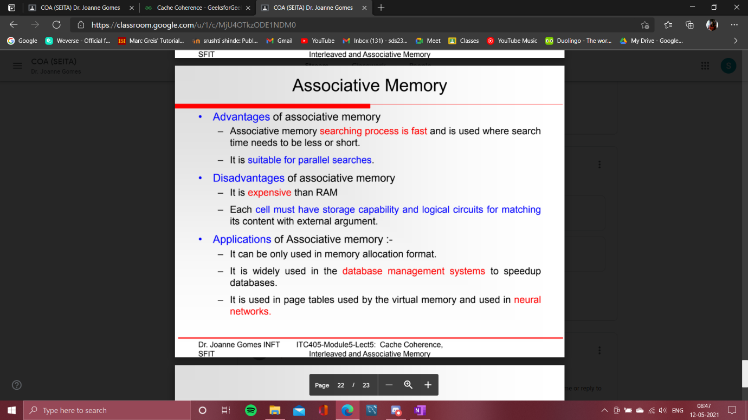

Associative Memory

An associative memory can be considered as a memory unit whose stored data can be identified for access by the content of the data itself rather than by an address or memory location.

Associative memory is often referred to as **Content Addressable Memory (CAM)**.

When a write operation is performed on associative memory, no address or memory location is given to the word. The memory itself is capable of finding an empty unused location to store the word.

On the other hand, when the word is to be read from an associative memory, the content of the word, or part of the word, is specified. The words which match the specified content are located by the memory and are marked for reading.

The following diagram shows the block representation of an Associative memory.

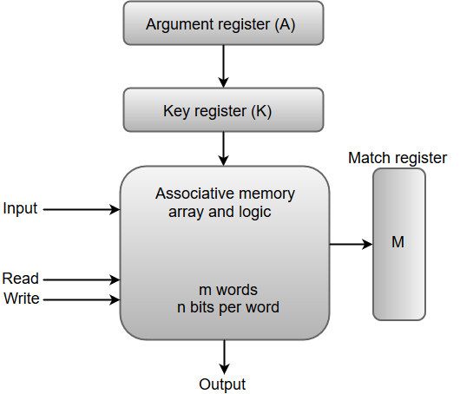

From the block diagram, we can say that an associative memory consists of a memory array and logic for 'm' words with 'n' bits per word.

The functional registers like the argument register **A** and key register **K** each have **n** bits, one for each bit of a word. The match register **M** consists of **m** bits, one for each memory word.

The words which are kept in the memory are compared in parallel with the content of the argument register.

The key register (K) provides a mask for choosing a particular field or key in the argument word. If the key register contains a binary value of all 1's, then the entire argument is compared with each memory word. Otherwise, only those bits in the argument that have 1's in their corresponding position of the key register are compared. Thus, the key provides a mask for identifying a piece of information which specifies how the reference to memory is made.

The following diagram can represent the relation between the memory array and the external registers in an associative memory.

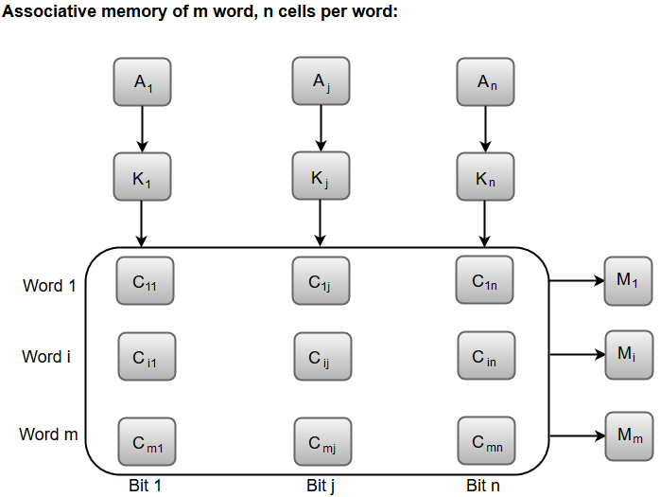

The cells present inside the memory array are marked by the letter C with two subscripts. The first subscript gives the word number and the second specifies the bit position in the word. For instance, the cell Cij is the cell for bit **j** in word **i**.

A bit Aj in the argument register is compared with all the bits in column **j** of the array provided that Kj = 1. This process is done for all columns **j** = 1, 2, 3......, n.

If a match occurs between all the unmasked bits of the argument and the bits in word **i**, the corresponding bit Mi in the match register is set to 1. If one or more unmasked bits of the argument and the word do not match, Mi is cleared to 0.

*From <*[*https://www.javatpoint.com/coa-associative-memory*](https://www.javatpoint.com/coa-associative-memory)*>*

Cache Memory

The data or contents of the main memory that are used frequently by CPU are stored in the cache memory so that the processor can easily access that data in a shorter time. Whenever the CPU needs to access memory, it first checks the cache memory. If the data is not found in cache memory, then the CPU moves into the main memory.

Cache memory is placed between the CPU and the main memory. The block diagram for a cache memory can be represented as:

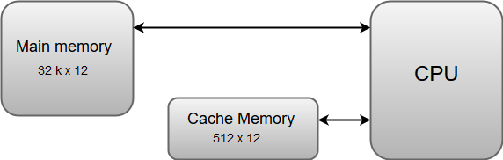

The cache is the fastest component in the memory hierarchy and approaches the speed of CPU components.

The basic operation of a cache memory is as follows:

* + When the CPU needs to access memory, the cache is examined. If the word is found in the cache, it is read from the fast memory.
  + If the word addressed by the CPU is not found in the cache, the main memory is accessed to read the word.
  + A block of words one just accessed is then transferred from main memory to cache memory. The block size may vary from one word (the one just accessed) to about 16 words adjacent to the one just accessed.
  + The performance of the cache memory is frequently measured in terms of a quantity called **hit ratio**.
  + When the CPU refers to memory and finds the word in cache, it is said to produce a **hit**.
  + If the word is not found in the cache, it is in main memory and it counts as a **miss**.
  + The ratio of the number of hits divided by the total CPU references to memory (hits plus misses) is the hit ratio.

*From <*[*https://www.javatpoint.com/coa-cache-memory*](https://www.javatpoint.com/coa-cache-memory)*>*

Types of Memory Interleaving

* + Difficulty Level : [Medium](https://www.geeksforgeeks.org/medium/)
  + Last Updated : 28 Apr, 2020

[Memory Interleaving](https://www.geeksforgeeks.org/memory-interleaving/) is an abstraction technique which divides memory into a number of modules such that successive words in the address space are placed in the different module.

Suppose a 64 MB memory made up of the 4 MB chips as shown in the below:

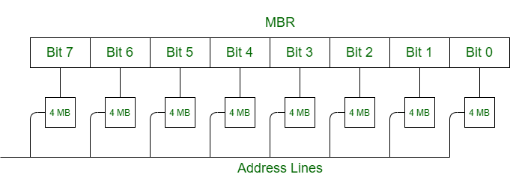

We organize the memory into 4 MB banks, each having eight of the 4 MB chips. The memory thus has 16 banks, each of 4 MB.

64 MB memory = 2^26, so 26 bits are used for addressing.

16 = 2^4, so 4 bits of address select the bank, and 4 MB = 2^22, so 22 bits of address to each chip.

In general, an N-bit address, with N = L + M, is broken into two parts:

* + L-bit bank select, used to activate one of the 2^L banks of memory, and
  + M-bit address that is sent to each of the memory banks.

When one of the memory banks is active, the other (2L – 1) are inactive. All banks receive the M-bit address, but the inactive one do not respond to it.

**Classification of Memory Interleaving:**

Memory interleaving is classified into two types:

**1. High Order Interleaving –**

In high-order interleaving, the most significant bits of the address select the memory chip. The least significant bits are sent as addresses to each chip. One problem is that consecutive addresses tend to be in the same chip. The maximum rate of data transfer is limited by the memory cycle time.

It is also known as Memory Banking.

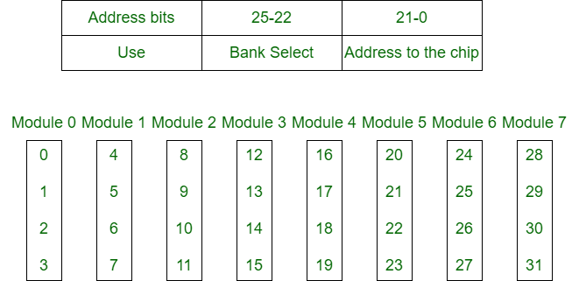

**2. Low Order Interleaving –**

In low-order interleaving, the least significant bits select the memory bank (module). In this, consecutive memory addresses are in different memory modules. This allows memory access at much faster rates than allowed by the cycle time.

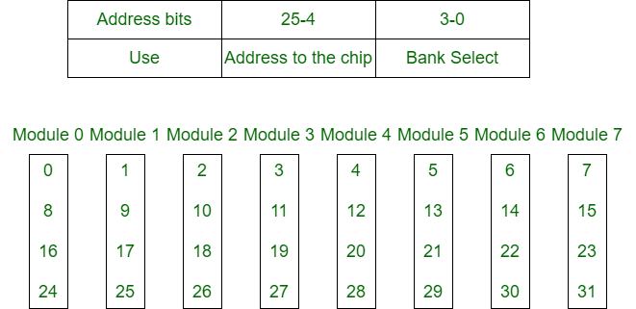

*From <*[*https://www.geeksforgeeks.org/types-of-memory-interleaving/*](https://www.geeksforgeeks.org/types-of-memory-interleaving/)*>*